**Facebook Post Comment Volume Regression Analysis**

Ta-Hung (Denny) Chen

Department of Mathematics and Statistics

Boston University, Boston, Massachusetts, U.S

Instructor: Dr. Fotios Kokkotos

December, 12, 2023

**Abstract**

In the dynamic realm of social media, the volume of comments a Facebook post garners serves as a crucial indicator of its engagement and reach. This study delves into the predictive factors influencing comment volume, utilizing the Facebook Comment Volume Dataset from the UCI Machine Learning Repository. Our research leverages mixed effect model to construct a negative binomial regression that predicts the number of comments a post is likely to receive within the subsequent hours of its publication. Drawing on the work of Kamaljot Singh and others, I employed count data regression methods and its extensions to account for potential overdispersion. By examining various post features, such as page characteristics, essential and weekday features, and other basic attributes, I endeavor to identify the key determinants of comment volume. The model's accuracy will be assessed using Mean Absolute Percentage Error (MAPE), Root Mean Squared Error (RMSE), and Mean Absolute Error (MAE), alongside Posterior Predictive Check plots. Our findings aim to empower content creators and social media strategists to amplify their online presence and foster organic user interactions effectively. By providing insights into the promotion of Facebook posts without relying on paid advertising, this research seeks to democratize the approach to enhancing social media visibility.

**Introduction:**

The study focuses on forecasting Facebook comment volumes using mixed effect regression models, essential for gauging social media engagement. As online interactions dominate today's social sphere, predicting user engagement on Facebook is key for creators and marketers. This research utilizes the Facebook Comment Volume Dataset by Singh and Kaur (2015) to analyze the comments a post receives in the first three days—critical for assessing user interaction. The dataset provides features related to the posts for a detailed examination of the factors affecting comment volumes. Count data regression modeling, starting with Poisson regression, is the methodology used, with flexibility to adapt to other models in case of data overdispersion. The research aims to identify factors that significantly affect Facebook comment volumes and to test the predictive performance of the models. The findings are intended to enhance social media engagement strategies. In essence, this paper advances social media analytics by applying a hierarchical model to predict and understand Facebook user engagement.

**Datasets:**

The analysis conducted in this research is based on data sourced from the Comment Volume Prediction using Neural Networks and Decision Trees, originally collected by Singh and Kaur (2015) and made available through the UCI Machine Learning Repository. The dataset originates from Facebook Pages and has been meticulously prepared to facilitate the study of comment volume on posts. According to the authors of the research that produced the data, it is presumed that only comments posted within the last three days relative to a given Base date/time[1] are relevant, as older posts are not typically expected to gain further engagement.

To ensure data integrity, any posts lacking comments or other essential information have been excluded. The dataset is divided into two parts: training and testing. The training data encompasses post information collected at five distinct time intervals, resulting in five different data variants.[2] The fifth dataset, known as *Data Variant 5*, has been selected for analysis due to its comprehensive nature and the richness of its observations. Regarding the testing dataset, it comprises 10 test cases, each with 100 observations, and is merged together.

Predictors contain (1) Page features, (2) Essential features, (3) Weekday features, (4) Other basic features. Followed the feature definition by Singh and Kaur (2015).

1. Page features:

Four features of the category were identified to define the characteristic of the post. *Page likes:* It is a feature that defines users support for specific comments, pictures, wall posts, statuses, or pages. *Page Category:* This defined the category of source of document eg: local business or place, brand, or product, company or institution, artist, band, entertainment, community, etc. *Page Check in’s:* The feature shows the presence of the post at particular place. *Page Talking About:* The actual count of users who are “engaged” and interacting with the Page. Including the activities such as comments, likes, shares.

1. Essential features:

Essential features indicate the pattern of comments on the post within various time interval with reference to random select Base date/time. *CC1:* Total comment count within 72 hours before the selected Base date/time. *CC2:* Comment count in last 24 hours w.r.t to the selected Base date/time. *CC3:* Comment count between last 24 hours to last 48 hours w.r.t to the selected Base date/time. *CC4:* Comment count in first 24 hours w.r.t the selected Base date/time. *CC5:* the difference between *CC2* and *CC3*. And the data also contains min, max, standard deviation, median, and mean of *CC1* to *CC5*.

1. Weekday features:

Weekday features represent as a binary indicator showing the day on which the post was published and the day on selected Base date/time.

1. Other basic features:

Other basic features show additional information of the post, including the length of the document, time gap between selected Base date/time and document published ranges from [0,72], document promotion status, and post share count.

**Methodology:**

The problem planned to be addressed using a count data regression predictive modeling approach, with Poisson regression initially employed. There is flexibility to modify the regression assumptions to better align with the data and yield accurate results. For instance, should overdispersion be detected within the data, alternative models such as Quasi-Poisson or negative binomial regression may be utilized.

* Potential assumption adjustment for Poisson model:
* Quasi-Poisson regression:

$$\log\left(μ_{i}\right)=β_{0}+β_{1}X_{1_{i}}+β_{2}X_{2_{i}}+…$$

Where:

$μ:$ Expected value of the observation $i$.

$β_{0},β_{1},β_{2},…$: Coefficient to be estimated.

$X_{1_{i}}, {X_{2}}_{i},…$: Predictors’ value for observation $i$.

Variance for Quasi-Poisson:

$$var\left(Y\right)=μ∙ϕ, ϕ>1$$

$ϕ$ is the dispersion coefficient. While $ϕ=1$ is a Poisson distribution with assumptions of parameters $λ=μ=var(Y)$.

* Negative binomial regression:

$$\log\left(μ_{i}\right)=β_{0}+β_{1}X_{1_{i}}+β_{2}X_{2_{i}}+…$$

Where:

$μ:$ Expected value of the observation $i$.

$β_{0},β_{1},β_{2},…$: Coefficient to be estimated.

$X_{1_{i}}, {X_{2}}_{i},…$: Predictors’ value for observation $i$.

Variance for negative binomial regression:

$$var\left(Y\right)=μ+αμ^{2}=μ+\frac{μ^{2}}{k}$$

$α, k$ are the dispersion parameter in different presenting form. While $α=0$, or $k→∞$, negative binomial model converges to a Poisson distribution with assumptions of parameters $λ=μ=var(Y)$.

* Zero inflation model:

Since overdispersion is often observed in counting data problem, a zero-inflation negative binomial regression will be adopted if required. It combines two parts, the count model and the zero-inflation model.

1. Count Model (Negative Binomial Part): Same as the description of negative binomial regression above.
2. Zero-inflation Model:

$$logit\left(π_{i}\right)= α_{0}+α_{1}Z_{i1}+α_{2}Z_{i2}+…+α_{l}Z_{il}$$

Where:

$π_{i}$: is the probability of $i$-th observation is an “extra” zero.

$Z_{i1}, Z_{i2},…, Z_{il}$: the independent variables for the zero-inflation part.

$α_{0}, α_{1},α_{2}, …, α_{l}$: the coefficients for the zero-inflation part.

**Validation:**

Mean Squared Error (RMSE) and Mean Absolute Percentage Error (MAPE) will be used to evaluate the accuracy for the regression problem.

$$MSE=\frac{1}{n}\sum_{i=1}^{N}{{\left(y-\hat{y}\right)}^{2}}$$

$$MAPE=\frac{1}{n}\sum_{i=1}^{N}{\left|\frac{y_{i}-{\hat{y}}_{i}}{y_{i}}\right|}$$

Root Mean Squared Error (RMSE), Mean Absolute Error (MAE), Posterior Predicting Check plot are planned to be considered to evaluate the fitness of the regression model.

$$RMSE=\sqrt{MSE}=\sqrt{\frac{1}{n}\sum_{i=1}^{N}{{\left(y-\hat{y}\right)}^{2}}}$$

$$MAE=\frac{1}{n}\sum_{i=1}^{N}{\left|y-\hat{y}\right|}$$

**Quantitative Analysis:**

Exploratory Data Analysis:

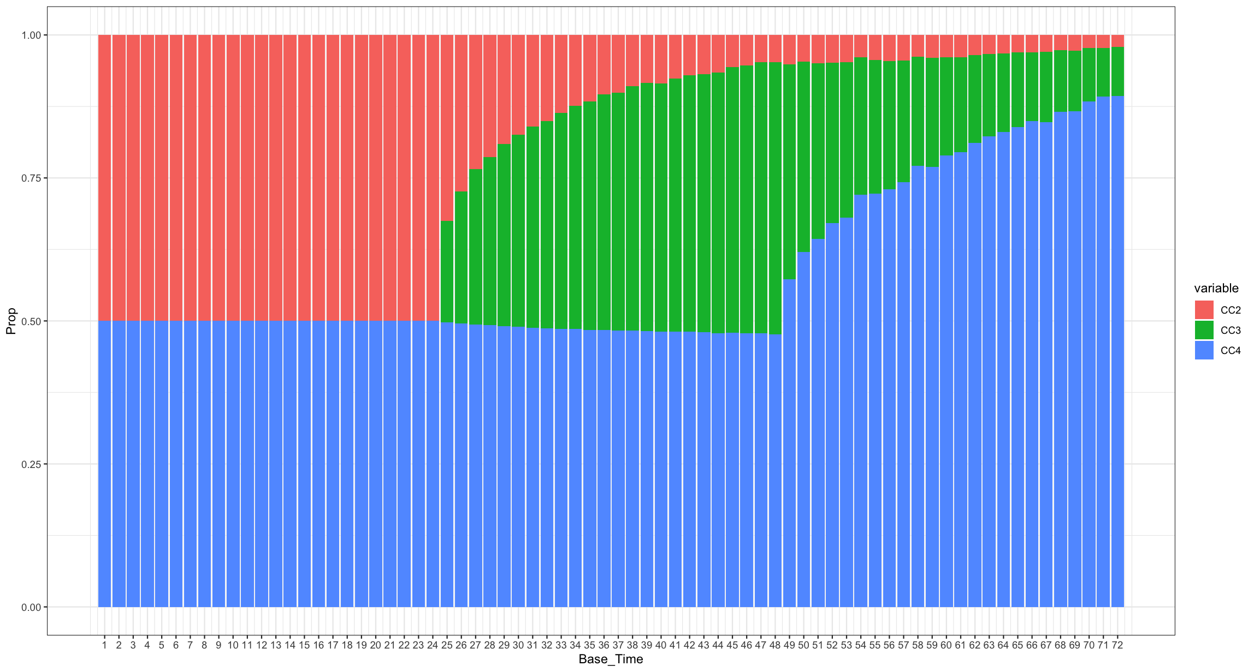 Most of the data cleansing and manipulation work had been done by Singh and Kaur (2015), and I directly started the analysis based on the cleaned and well-organized data which is available through UCI- Machine Learning Repository. Refer to what I have mentioned in the Datasets section is that *CC4* is the comment volume in the first 24 hours, and *CC2* is the comment volume in last 24 hours w.r.t to the selected Base date/time, which means, if the Base date/time is selected within 24 hours after the post was published, then *CC2* equals to *CC4*, shown in Figure 1. From Figure 1, we can observe that most of the comment are posted with the first 24 hour after the post was published. And it meets the assumption of “Only comments posted within the last three days relative to a given base date/time are relevant, as older posts are not typically expected to gain further engagement.”

Figure 1. Proportion of CC2, CC3, CC4 to Base_Time

Feature Engineering:

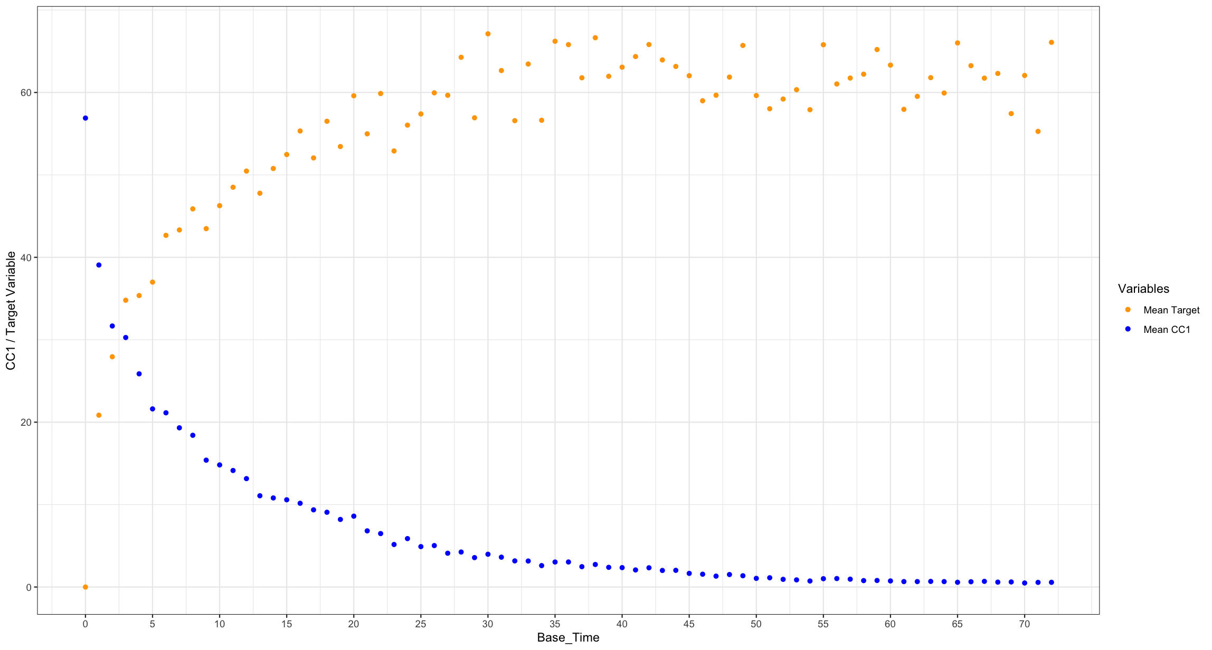 The analysis aimed to tackle with a count data problem. In a Poisson regression model, offset is often considered when designing the regression. After observing the *Target_Variable* to the *Base_Time,* shown in Figure 2. Refer to Appendix.2, Base_Time means the hour from the selected Base date/time and to the time of the post published. We can see that the *Target_Variable* looks like a cumulative volume estimation of the post comment, so an offset term is considered in this analysis.

Figure 2. Patterns of Mean Target_Variable and CC1 in each Base_Time

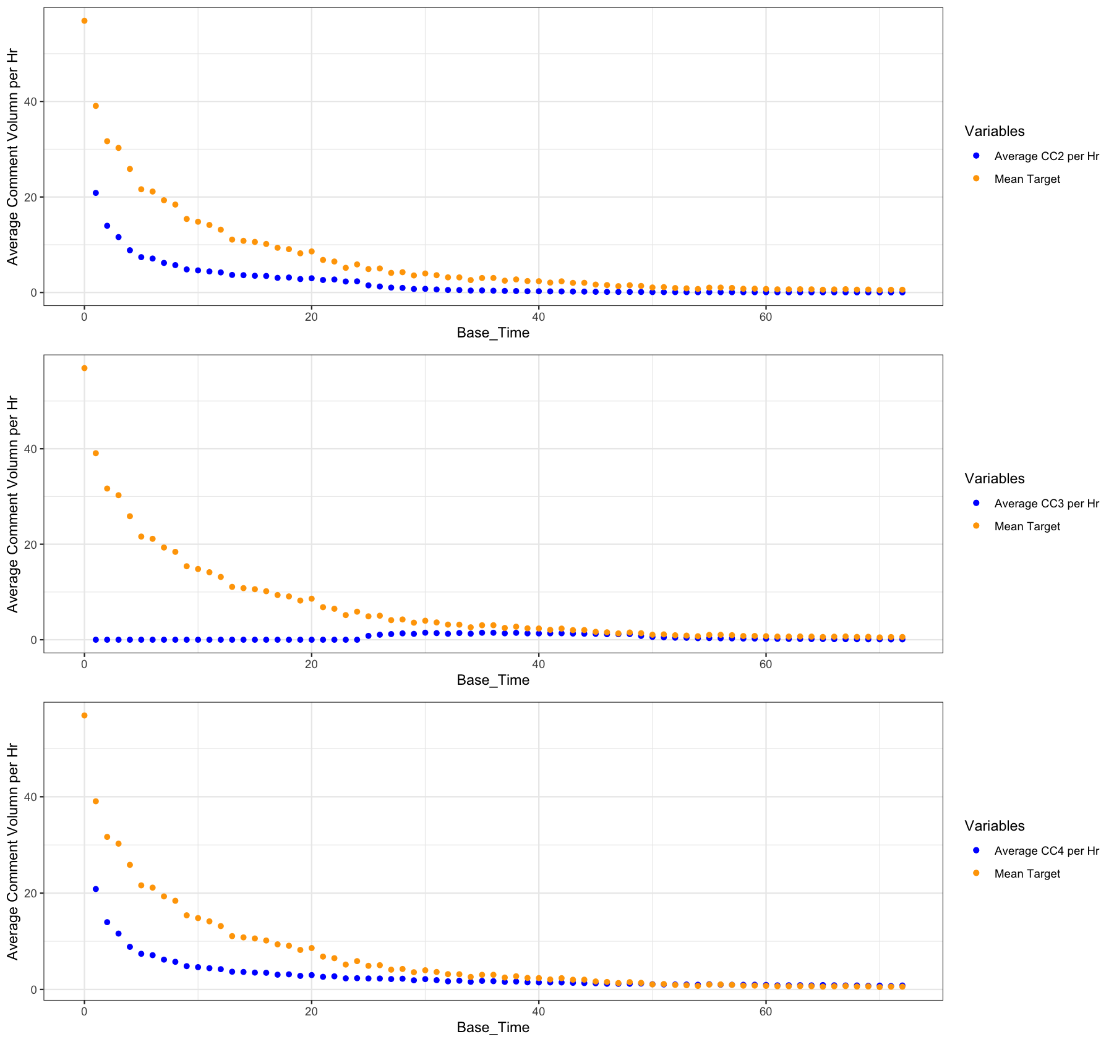 Being interested in the average comment volume within every hour w.r.t the selected Base date/time, three new variables are created, *CC2_per_hr, CC3_per_hr, CC4_per_hr*, shown in Figure 3.

Scales of predictors in regression analysis are also critical to estimate the estimands. The original data are highly skewed, and scale (range of the column) varies dramatically between variables. From Figure 4, I projected the data points to *CC1* and *Page_Popularity_Likes*. It is 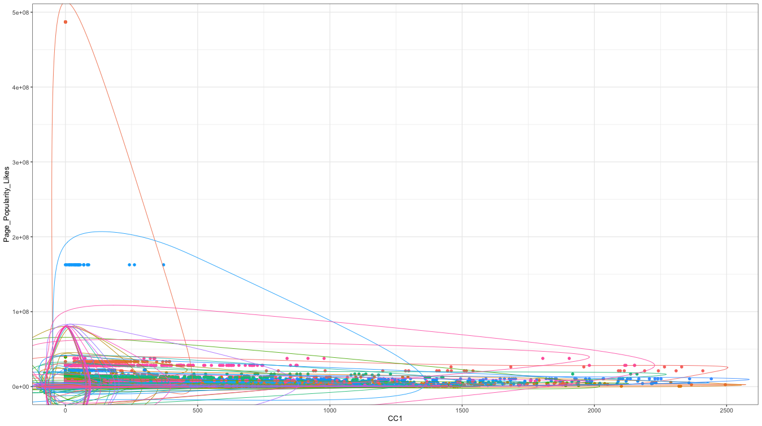obvious that the data scale varies drastically, and high skewness occurs. So I decided to perform a log transformation, and normalize the variable to make the distribution looks more like a bell-shaped, shown in Figure 5. *CC1, CC2, CC3, CC4, Page_Popularity_Likes, Page_Checkins, Page_Talking_About, Post_Length, Post_Share_Count, CC2_per_hr, CC3_per_hr, CC4_per_hr* are addressed by the log transformation and normalization.From Figure 5, we can see that the serious 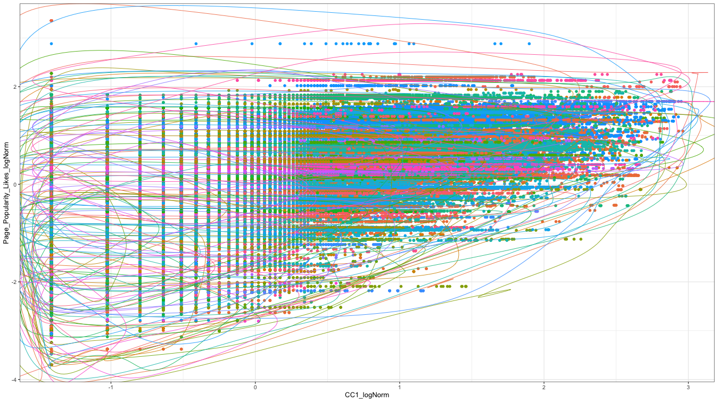skewness and largely varying scale of the axis range had been mitigated.

Figure 3. CC2_per_hr, CC3_per_hr, CC4_per_hr to Base_Time

Figure 4. Data projection before log transformation and normalization

Figure 5. Data projection after log transformation and normalization

Regression Analysis:

After creating new variables and solved the data scaling problems, I started the regression analysis. Considering the meaning of the variables, the final predictors are listed below.

* + - CC1_logNorm
    - CC2_logNorm
    - CC3_logNorm
    - CC4_logNorm
    - CC5
    - Page_Popularity_Likes_logNorm
    - Page_Checkins_logNorm
    - Page_Talking_About_logNorm
    - Post_Length_logNorm
    - Post_Share_Count_logNorm
    - CC2_per_hr_logNorm
    - CC3_per_hr_logNorm
    - CC4_per_hr_logNorm

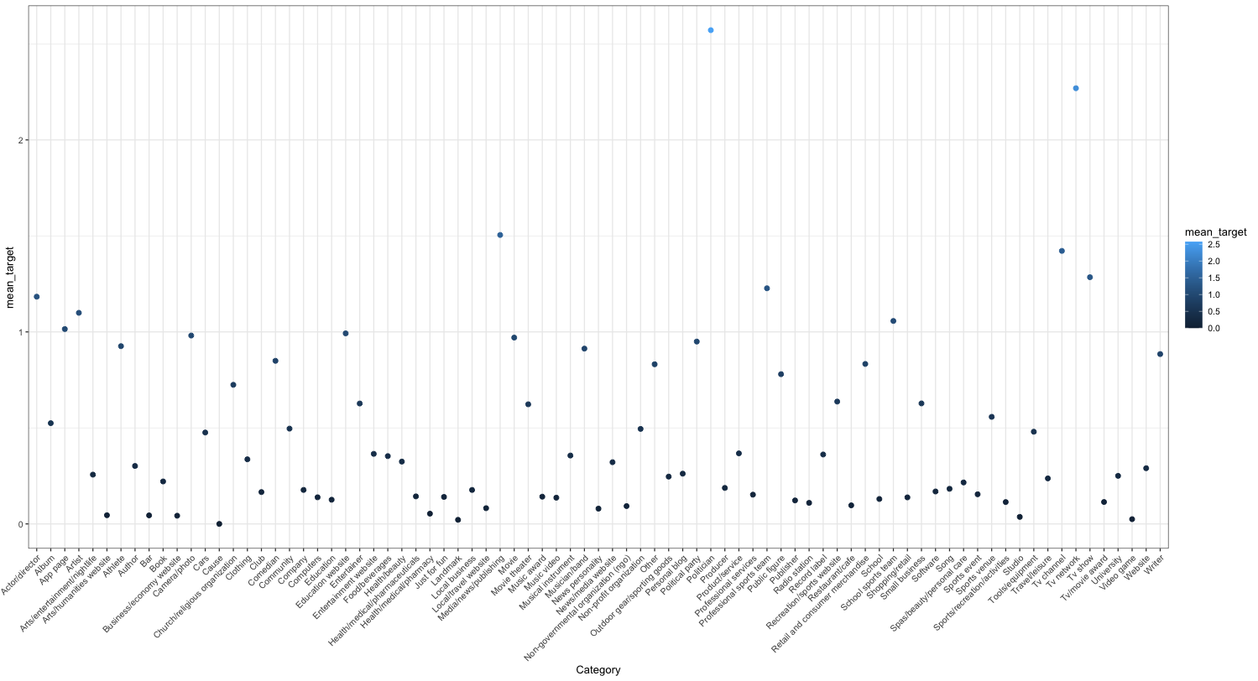And by observing different mean *Target_Variable* from the data, shown in Figure 6. A mixed effect model is planned to adopt in the analysis, and the random effect of the *Page_Category* will be estimated in the intercept to present the randomness of each *Category*.

Figure 6. Mean Target_Variable of each Page_Category

Initially, a Poisson regression, a classical approach for count data analysis, was employed. However, issues related to varying scales persisted in the data, rendering complete removal infeasible, leading to the Poisson model's inability to converge for coefficient estimation. Furthermore, the presence of overdispersion contradicted the fundamental Poisson assumption where the parameter $λ$ equals both the mean and the variance $μ=var\left(y\right)$. Contrastingly, the observed mean and variance of the response variable, *Target_Variable*, were 7.17 and 1176.37, respectively. Consequently, both Quasi-Poisson regression and negative binomial regression were implemented to tackle the overdispersion challenge. Additionally, a significant zero-inflation issue was identified during the fitting of the negative binomial model, which hindered estimation due to an excessive number of zeros. To address this, both a mixed-effect zero-inflation negative binomial regression model and a zero-inflation negative binomial regression model were utilized for the estimation process.

In summary, while two models, the Poisson regression and negative binomial regression, failed to complete fitting successfully, three others—Quasi-Poisson regression, zero-inflation negative binomial regression, and mixed-effect zero-inflation negative binomial regression model—achieved successful estimations.

**Results:**

*Mixed effect zero-inflation negative binomial regression:*

Table 1 and table 2 shows the result of estimation from the mixed effect zero-inflation negative binomial regression.

Table 1. Mixed Effect Zero Inflation Negative Binomial Regression Estimation - Counting Model

|  |  |  |  |  |  |
| --- | --- | --- | --- | --- | --- |
|  | **Estimate** | **Std.Error** | **z-value** | **Pr(>|z|)** | **Sig. Codes[3]** |
| (Intercept) | -2.0325 | 9.55E-02 | -21.278946 | 1.78E-100 | *** |
| CC1_logNorm | 2.1273 | 1.10E-01 | 19.333822 | 2.79E-83 | *** |
| CC2_logNorm | 1.3555 | 1.58E-02 | 85.547878 | 0.00E+00 | *** |
| CC3_logNorm | -0.3662 | 1.67E-02 | -21.951131 | 8.45E-107 | *** |
| CC4_logNorm | -6.6864 | 1.09E-01 | -61.130051 | 0.00E+00 | *** |
| CC5 | 0.0023 | 5.46E-05 | 42.490858 | 0.00E+00 | *** |
| Page_Popularity_Likes_logNorm | 0.1640 | 9.88E-03 | 16.596496 | 7.39E-62 | *** |
| Page_Checkins_logNorm | -0.0657 | 5.08E-03 | -12.942558 | 2.59E-38 | *** |
| Page_Talking_About_logNorm | 0.4274 | 1.03E-02 | 41.564859 | 0.00E+00 | *** |
| Post_Length_logNorm | -0.0096 | 4.68E-03 | -2.046945 | 4.07E-02 | * |
| Post_Share_Count_logNorm | 0.5317 | 5.10E-03 | 104.155868 | 0.00E+00 | *** |
| CC2_per_hr_logNorm | -1.3008 | 2.21E-02 | -58.77629 | 0.00E+00 | *** |
| CC3_per_hr_logNorm | 0.3840 | 1.36E-02 | 28.299609 | 3.49E-176 | *** |
| CC4_per_hr_logNorm | 3.5057 | 2.42E-02 | 144.826344 | 0.00E+00 | *** |

Table 2. Mixed Effect Zero Inflation Negative Binomial Regression Estimation - Zero Inflation Model

|  |  |  |  |  |  |
| --- | --- | --- | --- | --- | --- |
|  | **Estimate** | **Std.Error** | **z-value** | **Pr(>|z|)** | **Sig. Codes** |
| (Intercept) | -6.2229 | 1.30E-01 | -47.90495 | 0.00E+00 | *** |
| CC1_logNorm | -0.2641 | 1.26E-01 | -2.101095 | 3.56E-02 | * |
| CC2_logNorm | -0.8902 | 6.57E-02 | -13.545126 | 8.47E-42 | *** |
| CC3_logNorm | -0.1929 | 8.00E-02 | -2.409282 | 1.60E-02 | * |
| CC4_logNorm | 2.3936 | 1.38E-01 | 17.337545 | 2.45E-67 | *** |
| CC5 | 0.0257 | 1.60E-03 | 16.102157 | 2.46E-58 | *** |
| Page_Popularity_Likes_logNorm | -0.0243 | 1.62E-02 | -1.50385 | 1.33E-01 |  |
| Page_Checkins_logNorm | 0.0297 | 1.07E-02 | 2.774515 | 5.53E-03 | ** |
| Page_Talking_About_logNorm | -0.2316 | 1.71E-02 | -13.513238 | 1.31E-41 | *** |
| Post_Length_logNorm | -0.0739 | 9.23E-03 | -8.004249 | 1.20E-15 | *** |
| Post_Share_Count_logNorm | -0.4986 | 1.51E-02 | -33.044689 | 1.85E-239 | *** |
| CC2_per_hr_logNorm | 1.8643 | 3.63E-01 | 5.133092 | 2.85E-07 | *** |
| CC3_per_hr_logNorm | 0.7978 | 2.57E-01 | 3.10672 | 1.89E-03 | ** |
| CC4_per_hr_logNorm | -13.8657 | 3.77E-01 | -36.774507 | 4.72E-296 | *** |

The coefficient contains two parts of the estimation, one for counting model, which is the negative binomial regression model, and the second part is the estimation for extra zeros, which is the zero-inflation model. In prediction, for a given observation, the overall prediction involves using both parts of the model:

* If the zero-inflation model predicts a high probability for a zero ( $π_{i}$ is high), the observation is likely to be one of the extra zeros.
* If the zero-inflation model predicts a low probability for a zero ( $π_{i}$ is low), then the count prediction from the Negative Binomial part ($μ_{i}$) is used.

By focusing on the coefficients of *Page_Popularity_Likes_logNorm,* *Page_Talking_About_logNorm*, and *Post_Share_Count_logNorm*, it is evident that their magnitudes are significant enough to positively affect the response variable. Additionally, their small p-values underscore their statistical significance. Conversely, in the zero-inflation model, the coefficient of *CC4_per_hr_logNorm* is worth noting. This coefficient is remarkably large and is supported by a very small p-value, indicating its significance. This suggests that an increase in comment volume within the first 24 hours after a post's publication is associated with a lower likelihood of predicting an extra zero for that instance. Random effects for each *Page_Category* is shown in Appendix 4.

*Zero-inflation negative binomial regression:*

It is interesting to validate the result whether the *Page_Category* truly cause random effects among the data. So, a zero-inflation negative binomial regression is also fitted. Table 3 and Table 4 shows the result of estimation from the zero-inflation negative binomial regression.

Table 3. Zero Inflation Negative Binomial Regression Estimation - Counting Model

|  |  |  |  |  |  |
| --- | --- | --- | --- | --- | --- |
|  | **Estimate** | **Std.Error** | **z-value** | **Pr(>|z|)** | **Sig. Codes** |
| (Intercept) | -1.5592 | 6.15E-03 | -253.45914 | 0.00E+00 | *** |
| CC1_logNorm | 2.2077 | 1.15E-01 | 19.254813 | 1.29E-82 | *** |
| CC2_logNorm | 1.4049 | 1.63E-02 | 86.227307 | 0.00E+00 | *** |
| CC3_logNorm | -0.3138 | 1.73E-02 | -18.168251 | 9.21E-74 | *** |
| CC4_logNorm | -6.7877 | 1.14E-01 | -59.666976 | 0.00E+00 | *** |
| CC5 | 0.0023 | 5.47E-05 | 41.35275 | 0.00E+00 | *** |
| Page_Popularity_Likes_logNorm | 0.0244 | 7.82E-03 | 3.117069 | 1.83E-03 | ** |
| Page_Checkins_logNorm | -0.1414 | 4.19E-03 | -33.733925 | 1.84E-249 | *** |
| Page_Talking_About_logNorm | 0.4739 | 7.97E-03 | 59.479024 | 0.00E+00 | *** |
| Post_Length_logNorm | -0.0312 | 4.61E-03 | -6.778669 | 1.21E-11 | *** |
| Post_Share_Count_logNorm | 0.5100 | 4.87E-03 | 104.694198 | 0.00E+00 | *** |
| CC2_per_hr_logNorm | -1.3399 | 2.27E-02 | -59.026349 | 0.00E+00 | *** |
| CC3_per_hr_logNorm | 0.3398 | 1.40E-02 | 24.284428 | 2.86E-130 | *** |
| CC4_per_hr_logNorm | 3.5631 | 2.48E-02 | 143.568011 | 0.00E+00 | *** |
| Log(theta)[4] | -0.3333 | 5.39E-03 | -61.869171 | 0.00E+00 | *** |

Table 4. Zero Inflation Negative Binomial Regression Estimation – Zero Inflation Model

|  |  |  |  |  |  |
| --- | --- | --- | --- | --- | --- |
|  | **Estimate** | **Std.Error** | **z-value** | **Pr(>|z|)** | **Sig. Codes** |
| (Intercept) | -7.2710 | 9.68E-02 | -75.148371 | 0.00E+00 | *** |
| CC1_logNorm | -2.4026 | 1.29E-01 | -18.554244 | 7.54E-77 | *** |
| CC2_logNorm | -0.5172 | 6.17E-02 | -8.3790124 | 5.34E-17 | *** |
| CC3_logNorm | -0.0153 | 7.46E-02 | -0.2048657 | 8.38E-01 |  |
| CC4_logNorm | 2.2770 | 1.39E-01 | 16.3308768 | 5.95E-60 | *** |
| CC5 | 0.0157 | 1.42E-03 | 11.0352273 | 2.58E-28 | *** |
| Page_Popularity_Likes_logNorm | -0.0374 | 1.71E-02 | -2.1853984 | 2.89E-02 | * |
| Page_Checkins_logNorm | 0.0060 | 1.13E-02 | 0.5289232 | 5.97E-01 |  |
| Page_Talking_About_logNorm | -0.0655 | 1.80E-02 | -3.6337939 | 2.79E-04 | *** |
| Post_Length_logNorm | -0.0410 | 9.78E-03 | -4.1915444 | 2.77E-05 | *** |
| Post_Share_Count_logNorm | -0.2595 | 1.57E-02 | -16.532687 | 2.13E-61 | *** |
| CC2_per_hr_logNorm | 1.6518 | 3.30E-01 | 5.0061551 | 5.55E-07 | *** |
| CC3_per_hr_logNorm | 0.3787 | 2.28E-01 | 1.6591088 | 9.71E-02 | . |
| CC4_per_hr_logNorm | -8.3536 | 3.41E-01 | -24.487301 | 2.02E-132 | *** |

In the zero-inflation negative binomial regression model, coefficients for *Page_Talking_About_logNorm* and *Post_Share_Count_logNorm* positively influence the increase in comment volume. However, an intriguing observation emerges when examining the coefficients of *CC4_logNorm* and *CC4_per_hr_logNorm*. These coefficients display contrasting effects. Specifically, the model predicts a positive correlation between *CC4_logNorm* and the *Target_Variable*, which represents the total number of comments within the first 24 hours. In contrast, there is a negative correlation between *CC4_per_hr_logNorm* and the *Target_Variable*, which represent the comment volume in each hour on average. This finding presents a conflict with the predictions from the Negative Binomial model, which includes the random variability of *Page_Category*.

Quasi-Poisson Regression:

Despite the prevalence of zeros in the data, I initially overlooked them at the beginning of the study. Therefore, a quasi-Poisson regression somewhat reflects my preliminary assumptions about the data distribution and the design of the regression analysis.

Table 5. Quasi-Poisson Regression Estimation

|  |  |  |  |  |  |
| --- | --- | --- | --- | --- | --- |
|  | **Estimate** | **Std.Error** | **z-value** | **Pr(>|z|)** | **Sig. Codes** |
| (Intercept) | -2.9999 | 4.29E-02 | -69.960586 | 0.00E+00 | *** |
| CC1_logNorm | -2.6908 | 2.95E-01 | -9.133883 | 6.67E-20 | *** |
| CC2_logNorm | 2.4835 | 1.18E-01 | 21.050483 | 2.90E-98 | *** |
| CC3_logNorm | 0.3500 | 6.64E-02 | 5.271062 | 1.36E-07 | *** |
| CC4_logNorm | -1.2094 | 2.79E-01 | -4.341512 | 1.42E-05 | *** |
| CC5 | -0.0008 | 7.04E-05 | -11.557283 | 6.94E-31 | *** |
| Page_Popularity_Likes_logNorm | -0.0821 | 3.22E-02 | -2.550686 | 1.08E-02 | * |
| Page_Checkins_logNorm | -0.1706 | 1.43E-02 | -11.965933 | 5.50E-33 | *** |
| Page_Talking_About_logNorm | 0.8067 | 4.05E-02 | 19.915721 | 3.63E-88 | *** |
| Post_Length_logNorm | 0.0253 | 1.67E-02 | 1.510022 | 1.31E-01 |  |
| Post_Share_Count_logNorm | 0.4507 | 1.85E-02 | 24.412084 | 1.99E-131 | *** |
| CC2_per_hr_logNorm | -0.8208 | 1.08E-01 | -7.619805 | 2.55E-14 | *** |
| CC3_per_hr_logNorm | -0.3316 | 4.41E-02 | -7.511793 | 5.86E-14 | *** |
| CC4_per_hr_logNorm | 2.3337 | 1.16E-01 | 20.122124 | 5.81E-90 | *** |

In the Quasi-Poisson regression, coefficients for *Page_Talking_About_logNorm* and *Post_Share_Count_logNorm* are substantial and positively impact the *Target_Variable*. Furthermore, the coefficient for *CC4_per_hr_logNorm*, representing the average CC4 per hour within the first 24 hours, exhibits a positive effect. This contrasts with the coefficient for *CC4_logNorm*, which influences the *Target_Variable* in a negative direction.

Feature Selection:

After interpreting the results from these three models, it became evident that there is a significant correlation among the essential features (*CC1*, *CC2*, *CC3*, *CC4*), contributing to the volatility in estimation. Consequently, upon reviewing the correlation matrix for the selected covariates, as presented in Appendix 5, I decided to eliminate *CC1*, *CC2*, *CC3*, and their associated variables. The refined list of variables is as follows:

* + - CC4_logNorm
    - CC5
    - Page_Popularity_Likes_logNorm
    - Page_Checkins_logNorm
    - Page_Talking_About_logNorm
    - Post_Length_logNorm
    - Post_Share_Count_logNorm
    - CC4_per_hr_logNorm

Accordingly, a mixed-effect zero-inflation negative binomial model will be applied to analyze this new set of covariates. Table 6 and Table 7 show the estimation result of the Feature Selected Mixed Effect Zero-Inflation Negative Binomial regression.

Table 6. Feature Selected Mixed Effect Zero Inflation Negative Binomial Regression Model – Condition Model

|  |  |  |  |  |  |
| --- | --- | --- | --- | --- | --- |
|  | **Estimate** | **Std.Error** | **z-value** | **Pr(>|z|)** | **Sig. Codes** |
| (Intercept) | -0.7815 | 1.18E-01 | -6.614885 | 3.72E-11 | *** |
| CC4_logNorm | -0.7090 | 6.61E-03 | -107.25271 | 0.00E+00 | *** |
| CC5 | 0.0036 | 2.92E-05 | 124.605116 | 0.00E+00 | *** |
| Page_Popularity_Likes_logNorm | 0.4098 | 1.72E-02 | 23.810115 | 2.62E-125 | *** |
| Page_Checkins_logNorm | -0.1105 | 9.26E-03 | -11.937018 | 7.59E-33 | *** |
| Page_Talking_About_logNorm | 0.4901 | 1.66E-02 | 29.595444 | 1.71E-192 | *** |
| Post_Length_logNorm | -0.0447 | 8.72E-03 | -5.125318 | 2.97E-07 | *** |
| Post_Share_Count_logNorm | 0.8150 | 8.73E-03 | 93.314913 | 0.00E+00 | *** |

Table 7. Feature Selected Mixed Effect Zero Inflation Negative Binomial Regression Model – Zero Inflation Model

|  |  |  |  |  |  |
| --- | --- | --- | --- | --- | --- |
|  | **Estimate** | **Std.Error** | **z-value** | **Pr(>|z|)** | **Sig. Codes** |
| (Intercept) | -0.7815 | 1.18E-01 | -6.614885 | 3.72E-11 | *** |
| CC4_logNorm | -0.7090 | 6.61E-03 | -107.25271 | 0.00E+00 | *** |
| CC5 | 0.0036 | 2.92E-05 | 124.605116 | 0.00E+00 | *** |
| Page_Popularity_Likes_logNorm | 0.4098 | 1.72E-02 | 23.810115 | 2.62E-125 | *** |
| Page_Checkins_logNorm | -0.1105 | 9.26E-03 | -11.937018 | 7.59E-33 | *** |
| Page_Talking_About_logNorm | 0.4901 | 1.66E-02 | 29.595444 | 1.71E-192 | *** |
| Post_Length_logNorm | -0.0447 | 8.72E-03 | -5.125318 | 2.97E-07 | *** |
| Post_Share_Count_logNorm | 0.8150 | 8.73E-03 | 93.314913 | 0.00E+00 | *** |

Focusing on *CC4_logNorm*, the coefficient is observed to be negative. This can be attributed to the relationship between the number of comments received within the first 24 hours after a post is published and a fixed audience size. It implies that an increase in comment volume within this initial 24-hour period leads to a diminished effect on the overall hourly comment volume. This interpretation takes into consideration the offset term included in the model, suggesting that a higher initial comment volume negatively impacts subsequent hourly comment activity.

A Bayesian based mixed effect negative binomial regression is also fitted for comparison among different evaluation metrics.

Evaluation Metrics:

Table 8 shows the four performance metrics by the fitted data of regression models for each model.

Table 8. Performance Metric of Fitted Data

|  |  |  |  |  |
| --- | --- | --- | --- | --- |
| **Model** | **MSE** | **MAPE** | **RMSE** | **MAE** |
| Mixed Effect Zero Inflation Negative Binomial | 2,180,620 | 6.63 | 1,476.69 | 25.17 |
| Zero Inflation Negative Binomial | 11,461,908 | 9.40 | 3,385.54 | 33.51 |
| Quasi-Poisson | 783.83 | 0.93 | 28.00 | 5.46 |
| Feature Selected Mixed Effect Zero Inflation Negative Binomial | 492,908 | 22.94 | 702.07 | 45.73 |
| Null Model - Negative Binomial[5] | 1,176.39 | 4.34 | 34.30 | 10.66 |
| Negative Binomial - Bayesian Approach | 1,255.77 | 0.11 | 35.44 | 5.14 |

It is easy to observe that the Mixed Effect Zero Inflation Negative Binomial, Zero Inflation Negative Binomial, and Feature Selected Mixed Effect Zero Inflation Negative Binomial models exhibit large Mean Squared Errors (MSE). This is primarily due to the extremely large fitted values, which result in substantial residuals after squaring, an issue that also affects the Root Mean Squared Error (RMSE). Interestingly, all these models incorporate Zero Inflation model estimation, which, in this case, appears to adversely impact model fitting. The challenge seems to arise from the models' inability to simultaneously capture the extra zeros and the long-tailed distribution of the response variable. Focusing more on the extra zeros seems to actually generate more errors, highlighting a limitation in these models' capacity to balance these aspects effectively.

Residual Analysis:

In Generalized Linear Models (GLMs), the classical assumptions of normality and independence and identically distributed (iid) residuals, fundamental to ordinary linear regression, are modified. GLMs accommodate response variables following various distributions from the exponential family, such as binomial, Poisson, and normal. This framework incorporates a link function, connecting the mean of the response variable to the linear predictor. Crucially, the assumption of normally distributed residuals is relaxed; instead, residuals are expected to exhibit a distribution consistent with the chosen response distribution. While the normality of residuals is not a prerequisite, the independence of observations remains a critical assumption. Additionally, GLMs often account for heteroscedasticity, where the variance of residuals is a function of the mean, in contrast to the homoscedasticity assumption in linear regression. Residuals plots of each model are attached in Appendix 7 to Appendix 11.

**Prediction:**

Evaluation Metrics:

Table 9 shows the predictive result of the four performance metric for each model.

Table 9. Prediction Performance Metrics

|  |  |  |  |  |
| --- | --- | --- | --- | --- |
| **Model** | **MSE** | **MAPE** | **RMSE** | **MAE** |
| Mixed Effect Zero Inflation Negative Binomial | 11,620.43 | 3.68 | 107.80 | 29.77 |
| Zero Inflation Negative Binomial | 11,573.89 | 3.62 | 107.58 | 29.47 |
| Quasi-Poisson | 11,656.87 | 0.09 | 107.97 | 26.69 |
| Feature Selected Mixed Effect Zero Inflation Negative Binomial | 13,421,180 | 9.43 | 3,663.49 | 252.17 |
| Null Model - Negative Binomial[6] | 11,347.33 | 2.81 | 106.52 | 27.35 |
| Negative Binomial - Bayesian Approach | 11,660.67 | 0.47 | 107.98 | 26.51 |

The predictive analysis demonstrated that the Quasi-Poisson model, excluding Bayesian regression, outperformed all others in terms of Mean Absolute Percentage Error (MAPE). Interestingly, even though zero inflation issues were identified and addressed by specialized models, the inclusion of a zero inflation model did not markedly improve model fit in this instance. In fact, it makes things worse. Furthermore, it was observed that removing variables from the model did not enhance its performance compared to the original setup. This finding contradicts the initial thought of overfitting, as the performance metrics consistently reflected similar predictive results. Additionally, it is unfortunate that weekday features were excluded due to ambiguous definitions, a decision that potentially limited the interpretability of the findings.

**Conclusion:**

In conclusion, this research provides a comprehensive analysis of various regression models for predicting Facebook comment volumes. The study reveals the effectiveness of the Quasi-Poisson model in handling data with zero inflation issues, as evidenced by its superior performance in terms of Mean Absolute Percentage Error (MAPE). Additionally, the exploration of the Mixed Effect Zero-Inflation Negative Binomial model and Bayesian-based approaches offers insights into their capabilities and limitations in addressing the complexities of the data. The research underscores the effect of feature selection, as demonstrated by the decision to eliminate certain variables, which significantly impacted model outcomes. The findings highlight the nuanced balance needed in model selection and feature inclusion, especially when dealing with social media data characterized by zero inflation and long-tailed distributions. This study provides practical implications for effectively predicting engagement metrics like comment volumes on platforms like Facebook using regressions.

**References:**

* Singh, Kamaljot, Ranjeet Kaur Sandhu, and Dinesh Kumar. "Comment volume prediction using neural networks and decision trees." IEEE UKSim-AMSS 17th International Conference on Computer Modelling and Simulation, UKSim2015 (UKSim2015). 2015.
* Singh, Kamaljot. "Facebook comment volume prediction." *International Journal of Simulation: Systems, Science and Technologies* 16.5 (2015): 16-1.

**Appendix 1. Summary Statistics**

**Data Variant 5**

|  |  |  |  |  |  |
| --- | --- | --- | --- | --- | --- |
| **Statistic** | **N** | **Mean** | **St.Dev.** | **Min** | **Max** |
| Page_Category | 199,030 | 24.242 | 19.935 | 1 | 106 |
| Page_Popularity_Likes | 199,030 | 1,313,785.00 | 6,771,131.00 | 36 | 486,972,297 |
| Page_Checkins | 199,030 | 4,674.52 | 20,573.44 | 0 | 186,370 |
| Page_Talking_About | 199,030 | 44,771.73 | 110,898.30 | 0 | 6,089,942 |
| CC1_Min | 199,030 | 0.47 | 13.178 | 0 | 1,458 |
| CC1_Max | 199,030 | 485.318 | 538.194 | 0 | 2,495 |
| CC1_Avg | 199,030 | 55.901 | 86.515 | 0 | 2,031.00 |
| CC1_Median | 199,030 | 35.264 | 68.163 | 0 | 2,123.00 |
| CC1_Std | 199,030 | 68.091 | 82.411 | 0 | 762.358 |
| CC2_Min | 199,030 | 0.068 | 2.173 | 0 | 227 |
| CC2_Max | 199,030 | 381.499 | 439.634 | 0 | 2,119 |
| CC2_Avg | 199,030 | 21.815 | 35.693 | 0 | 973.25 |
| CC2_Median | 199,030 | 7.17 | 19.701 | 0 | 1,121.00 |
| CC2_Std | 199,030 | 40.514 | 51.561 | 0 | 683.596 |
| CC3_Min | 199,030 | 0.006 | 0.872 | 0 | 148 |
| CC3_Max | 199,030 | 380.723 | 430.183 | 0 | 2,095 |
| CC3_Avg | 199,030 | 19.992 | 31.568 | 0 | 660.75 |
| CC3_Median | 199,030 | 4.876 | 13.072 | 0 | 487 |
| CC3_Std | 199,030 | 40.712 | 52.598 | 0 | 801.468 |
| CC4_Min | 199,030 | 0.469 | 13.126 | 0 | 1,458 |
| CC4_Max | 199,030 | 434.882 | 490.73 | 0 | 2,184 |
| CC4_Avg | 199,030 | 52.754 | 81.02 | 0 | 1,868.50 |
| CC4_Median | 199,030 | 33.608 | 64.178 | 0 | 1,992.50 |
| CC4_Std | 199,030 | 63.461 | 76.836 | 0 | 680.962 |
| CC5_Min | 199,030 | -326.275 | 380.145 | -2,038 | 0 |
| CC5_Max | 199,030 | 377.323 | 436.702 | -101 | 2,119 |
| CC5_Avg | 199,030 | 1.822 | 9.69 | -184.4 | 496.6 |
| CC5_Median | 199,030 | -2.119 | 10.488 | -175 | 521 |
| CC5_Std | 199,030 | 56.54 | 74.583 | 0 | 1,386.40 |
| CC1 | 199,030 | 55.901 | 137.524 | 0 | 2,495 |
| CC2 | 199,030 | 21.815 | 74.658 | 0 | 2,119 |
| CC3 | 199,030 | 19.992 | 73.625 | 0 | 2,095 |
| CC4 | 199,030 | 52.754 | 128.434 | 0 | 2,184 |
| CC5 | 199,030 | 1.822 | 94.092 | -2,038 | 2,119 |
| Base_Time | 199,030 | 35.45 | 21.006 | 0 | 72 |
| Post_Length | 199,030 | 163.692 | 375.663 | 0 | 21,480 |
| Post_Share_Count | 199,030 | 117.363 | 954.359 | 1 | 144,860 |
| Post_Promotion_Status | 199,030 | 0 | 0 | 0 | 0 |
| H_Local | 199,030 | 23.783 | 1.827 | 1 | 24 |
| Post_Published_Weekday_40 | 199,030 | 0.122 | 0.328 | 0 | 1 |
| Post_Published_Weekday_41 | 199,030 | 0.143 | 0.35 | 0 | 1 |
| Post_Published_Weekday_42 | 199,030 | 0.149 | 0.357 | 0 | 1 |
| Post_Published_Weekday_43 | 199,030 | 0.157 | 0.364 | 0 | 1 |
| Post_Published_Weekday_44 | 199,030 | 0.144 | 0.351 | 0 | 1 |
| Post_Published_Weekday_45 | 199,030 | 0.146 | 0.353 | 0 | 1 |
| Post_Published_Weekday_46 | 199,030 | 0.137 | 0.344 | 0 | 1 |
| Base_DateTime_Weekday_47 | 199,030 | 0.139 | 0.346 | 0 | 1 |
| Base_DateTime_Weekday_48 | 199,030 | 0.135 | 0.342 | 0 | 1 |
| Base_DateTime_Weekday_49 | 199,030 | 0.137 | 0.344 | 0 | 1 |
| Base_DateTime_Weekday_50 | 199,030 | 0.147 | 0.354 | 0 | 1 |
| Base_DateTime_Weekday_51 | 199,030 | 0.155 | 0.362 | 0 | 1 |
| Base_DateTime_Weekday_52 | 199,030 | 0.144 | 0.351 | 0 | 1 |
| Base_DateTime_Weekday_53 | 199,030 | 0.142 | 0.349 | 0 | 1 |
| Target_Variable | 199,030 | 7.169 | 34.298 | 0 | 1,702 |
| CC2_per_hr | 199,030 | 2.098 | 10.597 | 0 | 1,011.00 |
| CC3_per_hr | 199,030 | 0.504 | 1.92 | 0 | 58.6 |
| CC4_per_hr | 199,030 | 2.768 | 10.785 | 0 | 1,011.00 |
| CC1_logNorm | 199,030 | 0 | 1 | -1.413 | 2.962 |
| CC2_logNorm | 199,030 | 0 | 1 | -0.929 | 3.866 |
| CC3_logNorm | 199,030 | 0 | 1 | -0.767 | 3.943 |
| CC4_logNorm | 199,030 | 0 | 1 | -1.397 | 2.93 |
| Page_Popularity_Likes_logNorm | 199,030 | 0 | 1 | -3.699 | 3.352 |
| Page_Checkins_logNorm | 199,030 | 0 | 1 | -0.643 | 2.838 |
| Page_Talking_About_logNorm | 199,030 | 0 | 1 | -2.717 | 2.364 |
| Post_Length_logNorm | 199,030 | 0 | 1 | -2.345 | 3.323 |
| Post_Share_Count_logNorm | 199,030 | 0 | 1 | -1.112 | 4.901 |
| CC2_per_hr_logNorm | 199,030 | 0 | 1 | -0.542 | 7.999 |
| CC3_per_hr_logNorm | 199,030 | 0 | 1 | -0.465 | 8.335 |
| CC4_per_hr_logNorm | 199,030 | 0 | 1 | -0.778 | 7.195 |

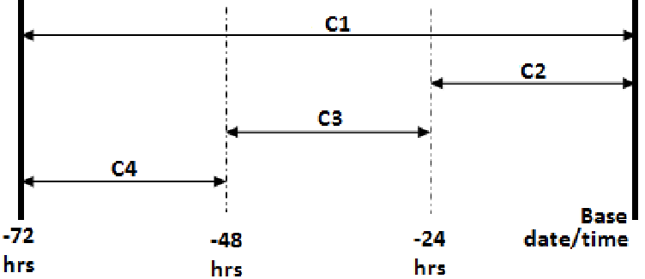**Appendix 2. Definition of CC1, CC2, CC3, CC4**

Reference:

* Singh, Kamaljot, Ranjeet Kaur Sandhu, and Dinesh Kumar. "Comment volume prediction using neural networks and decision trees." IEEE UKSim-AMSS 17th International Conference on Computer Modelling and Simulation, UKSim2015 (UKSim2015). 2015. Figure 2. Demonstrating the essential feature details.

**Appendix 3. Selected Base date/time and Data Variants**

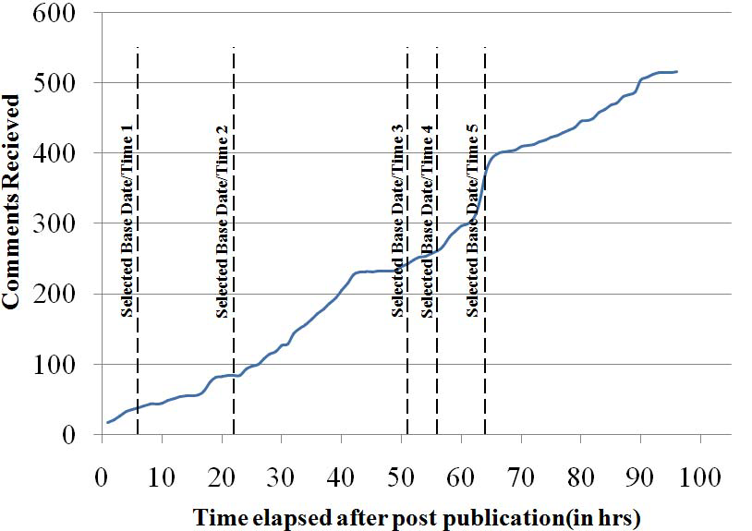

Reference:

* Singh, Kamaljot, Ranjeet Kaur Sandhu, and Dinesh Kumar. "Comment volume prediction using neural networks and decision trees." IEEE UKSim-AMSS 17th International Conference on Computer Modelling and Simulation, UKSim2015 (UKSim2015). 2015. Figure 3. Cumulative Comments and different selected base date/time.

**Appendix 4. Random effect in intercept of Mixed Effect Zero-Inflation Negative Binomial Regression Model**

|  |  |
| --- | --- |
|  | **(Intercept)** |
| **Actor/director** | 0.797691416002855 |
| **Album** | 1.45481231819863 |
| **App page** | 0.335323126318331 |
| **Artist** | 0.752756533780161 |
| **Arts/entertainment/nightlife** | 0.570816872757582 |
| **Arts/humanities website** | -0.722270126194794 |
| **Athlete** | 0.366450479118773 |
| **Author** | -0.12106639763402 |
| **Bar** | -0.928223930349228 |
| **Book** | 0.234561586233673 |
| **Business/economy website** | -2.28007195665994 |
| **Camera/photo** | -0.17352534636411 |
| **Cars** | -0.865934554135371 |
| **Cause** | -0.0309500108743655 |
| **Church/religious organization** | 0.93568102899322 |
| **Clothing** | -0.465299017798948 |
| **Club** | 0.471516759561997 |
| **Comedian** | -0.271051385439421 |
| **Community** | 0.922300765894157 |
| **Company** | 0.371478903710236 |
| **Computers** | -0.29465486402889 |
| **Education** | 0.251259557259128 |
| **Education website** | 0.307220727423639 |
| **Entertainer** | 0.748213395751029 |
| **Entertainment website** | -0.0257047879916132 |
| **Food/beverages** | -0.690744976361128 |
| **Health/beauty** | -0.273928873397458 |
| **Health/medical/pharmaceuticals** | -0.498513361764386 |
| **Health/medical/pharmacy** | -0.488630012219016 |
| **Just for fun** | -0.131296619001435 |
| **Landmark** | -0.755549492915212 |
| **Local business** | -0.315145403445216 |
| **Local/travel website** | -1.42795642304809 |
| **Media/news/publishing** | 0.93149958473011 |
| **Movie** | 0.463823621182598 |
| **Movie theater** | 1.17718881789451 |
| **Music award** | -0.499557791753261 |
| **Music video** | -0.0982061808845753 |
| **Musical instrument** | 0.830272757655659 |
| **Musician/band** | 0.653116383577719 |
| **News personality** | -1.05180790649609 |
| **News/media website** | -0.290747542809893 |
| **Non-governmental organization (ngo)** | -0.645099275334324 |
| **Non-profit organization** | -0.0363552617027611 |
| **Other** | 1.03530774989589 |
| **Outdoor gear/sporting goods** | -0.823000907462748 |
| **Personal blog** | -0.299202369530877 |
| **Political party** | 0.488278087640249 |
| **Politician** | 1.003187209019 |
| **Producer** | -0.432381453067569 |
| **Product/service** | -0.368180005813749 |
| **Professional services** | 0.154554392372236 |
| **Professional sports team** | 0.10894069597587 |
| **Public figure** | 0.884559827920183 |
| **Publisher** | -2.0980898561788 |
| **Radio station** | -0.456240048286791 |
| **Record label** | 0.119206624796966 |
| **Recreation/sports website** | -0.448078625179603 |
| **Restaurant/cafe** | 0.0301647819194763 |
| **Retail and consumer merchandise** | 0.5275719809678 |
| **School** | -0.32949395046109 |
| **School sports team** | 0.200767446671532 |
| **Shopping/retail** | -0.94736319911479 |
| **Small business** | 0.14074599393938 |
| **Software** | -0.793933506742064 |
| **Song** | -0.418155110560129 |
| **Spas/beauty/personal care** | -0.396258737086515 |
| **Sports event** | 0.146998127646654 |
| **Sports venue** | 1.77809218188632 |
| **Sports/recreation/activities** | 1.06258542110691 |
| **Studio** | -0.106930344201876 |
| **Tools/equipment** | 0.0269472353308642 |
| **Travel/leisure** | -1.05836457879078 |
| **Tv channel** | 0.706075037648395 |
| **Tv network** | -0.0943614323275968 |
| **Tv show** | 2.15279209093202 |
| **Tv/movie award** | -0.793964542442658 |
| **University** | 0.449464358638077 |
| **Video game** | -1.5435171473406 |
| **Website** | 0.00814223070591014 |
| **Writer** | 0.814248014629271 |

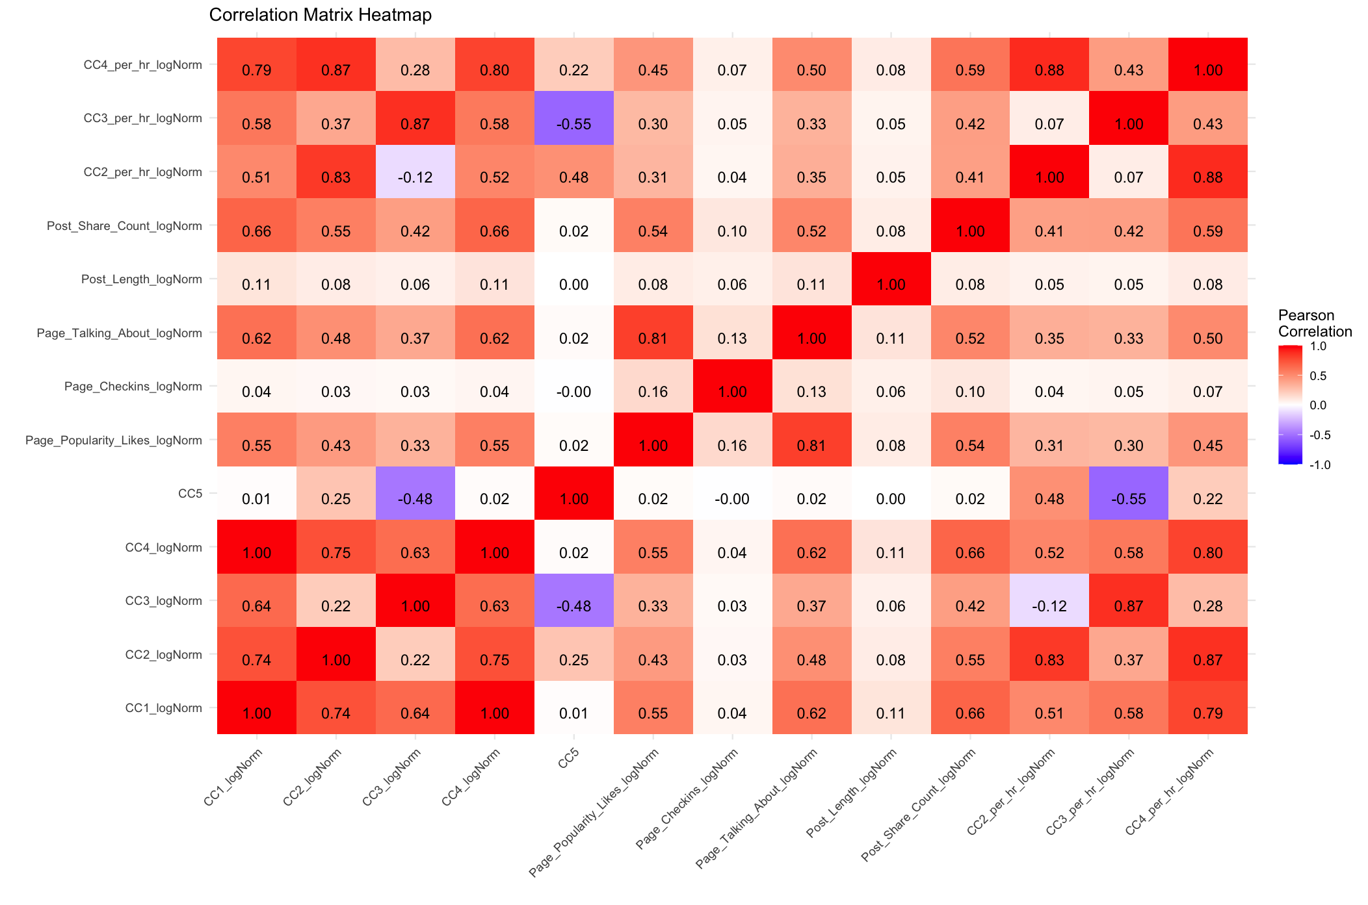**Appendix 5. Correlation for Selected Covariates**

**Appendix 6. Null Model Summary**

|  |
| --- |
| Family: nbinom2 ( log )  Formula: Target_Variable ~ 1  Data: fv5_train  AIC BIC logLik deviance df.resid  845937.5 845957.9 -422966.7 845933.5 199028  Dispersion parameter for nbinom2 family (): 0.139  Conditional model:  Estimate Std. Error z value Pr(>|z|)  (Intercept) 1.969725 0.006061 325 <2e-16 ***  ---  Signif. codes: 0 ‘***’ 0.001 ‘**’ 0.01 ‘*’ 0.05 ‘.’ 0.1 ‘ ’ 1 |

**Appendix 7. Residual Analysis - Feature Selected Mixed Effect Zero Inflation Negative Binomial Regression Model**

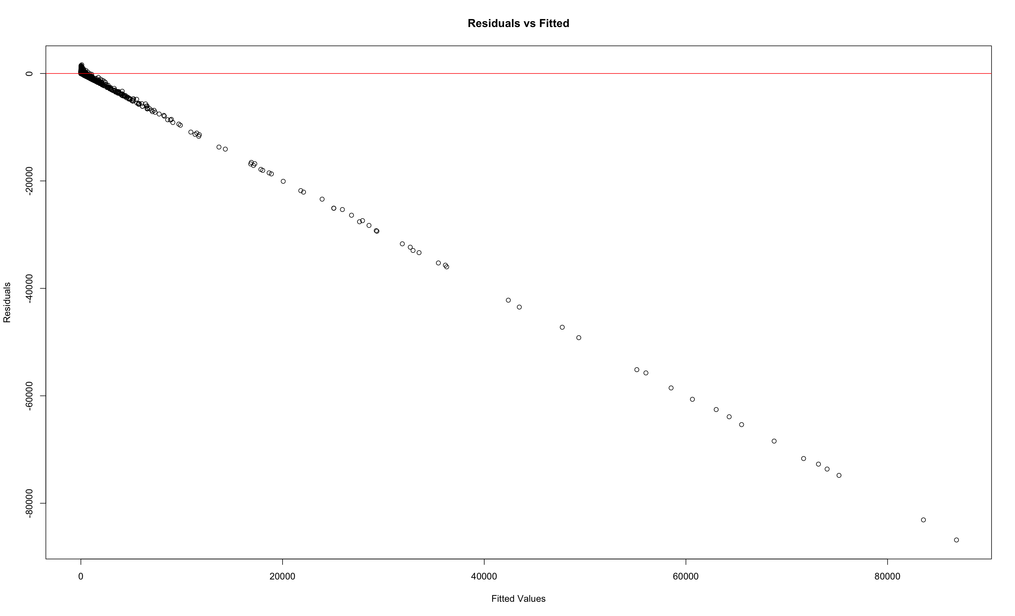Residual Plots:

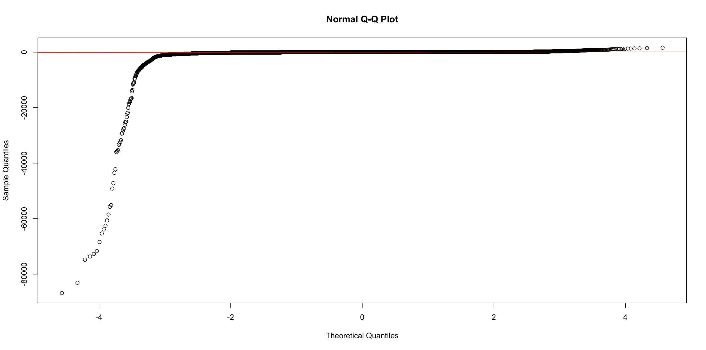QQ-Plot:

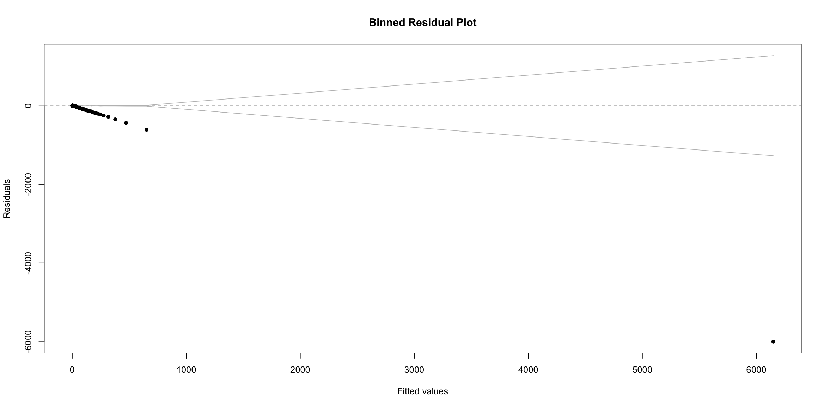Binned Residual Plot:

**Appendix 8. Residual Analysis - Mixed Effect Zero Inflation Negative Binomial Regression Model**

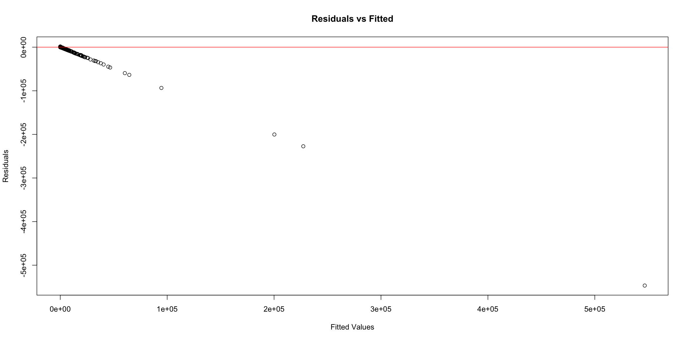Residual Plots:

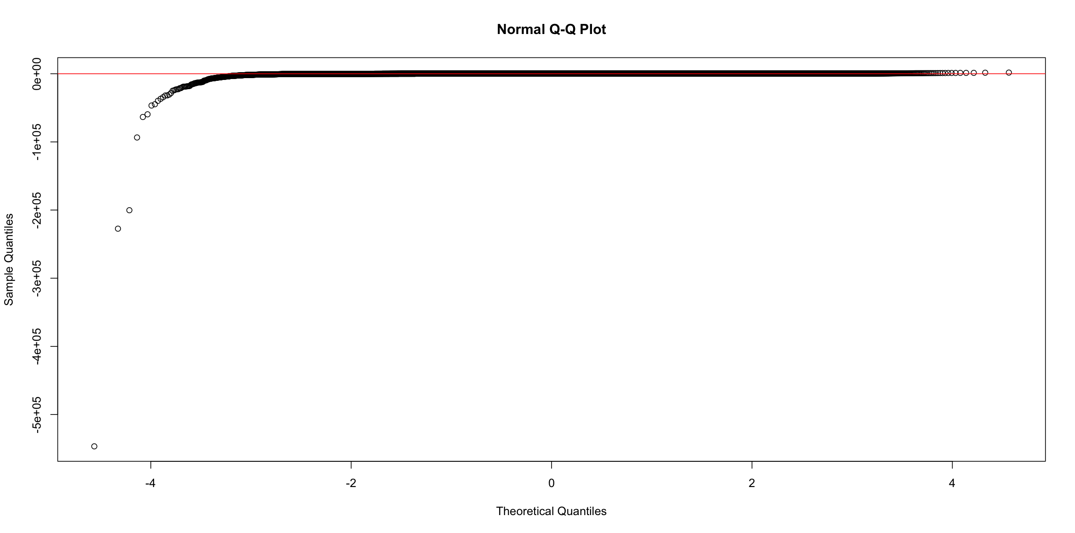QQ-Plot:

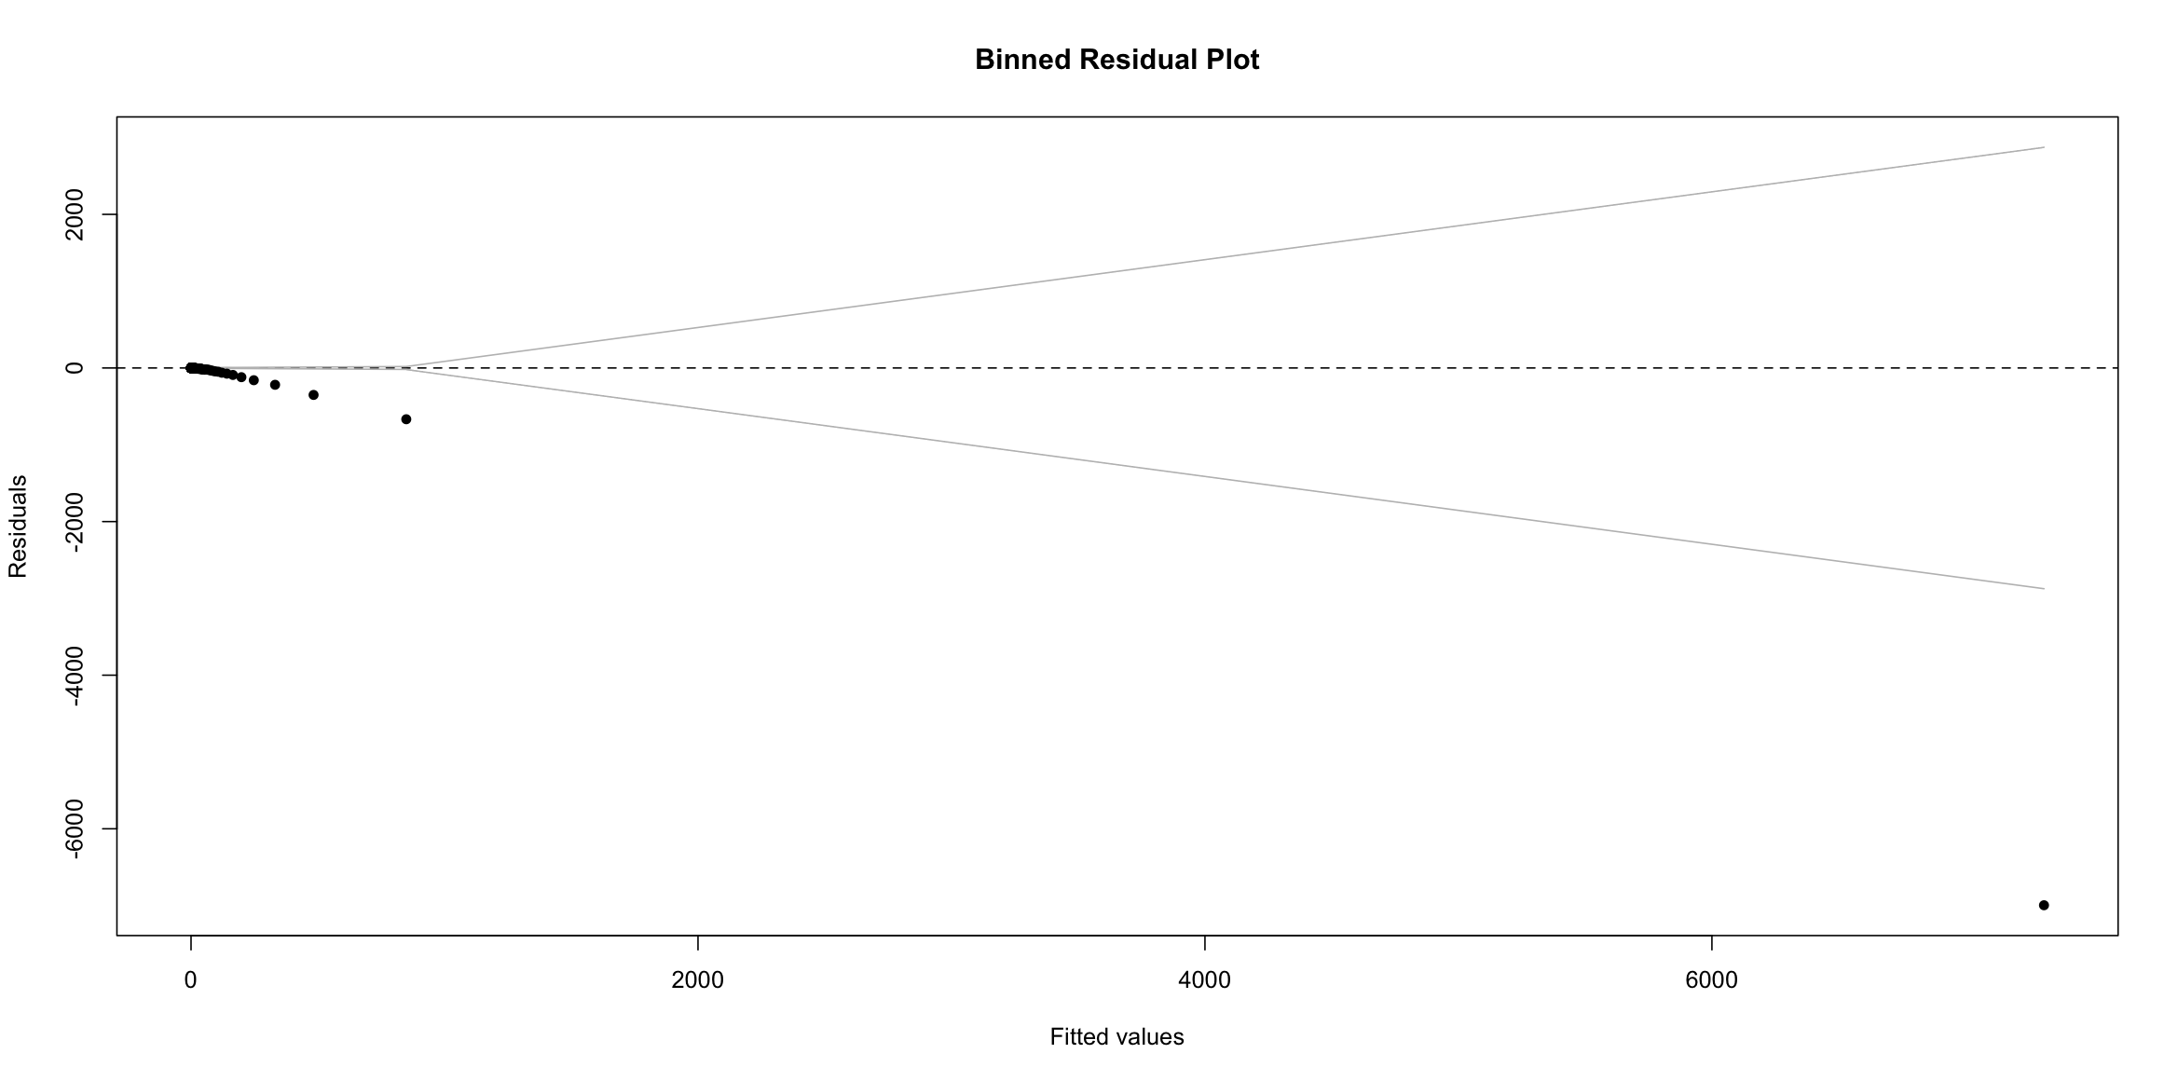Binned Residual Plot:

**Appendix 9. Residual Analysis - Zero Inflation Negative Binomial Regression Model**

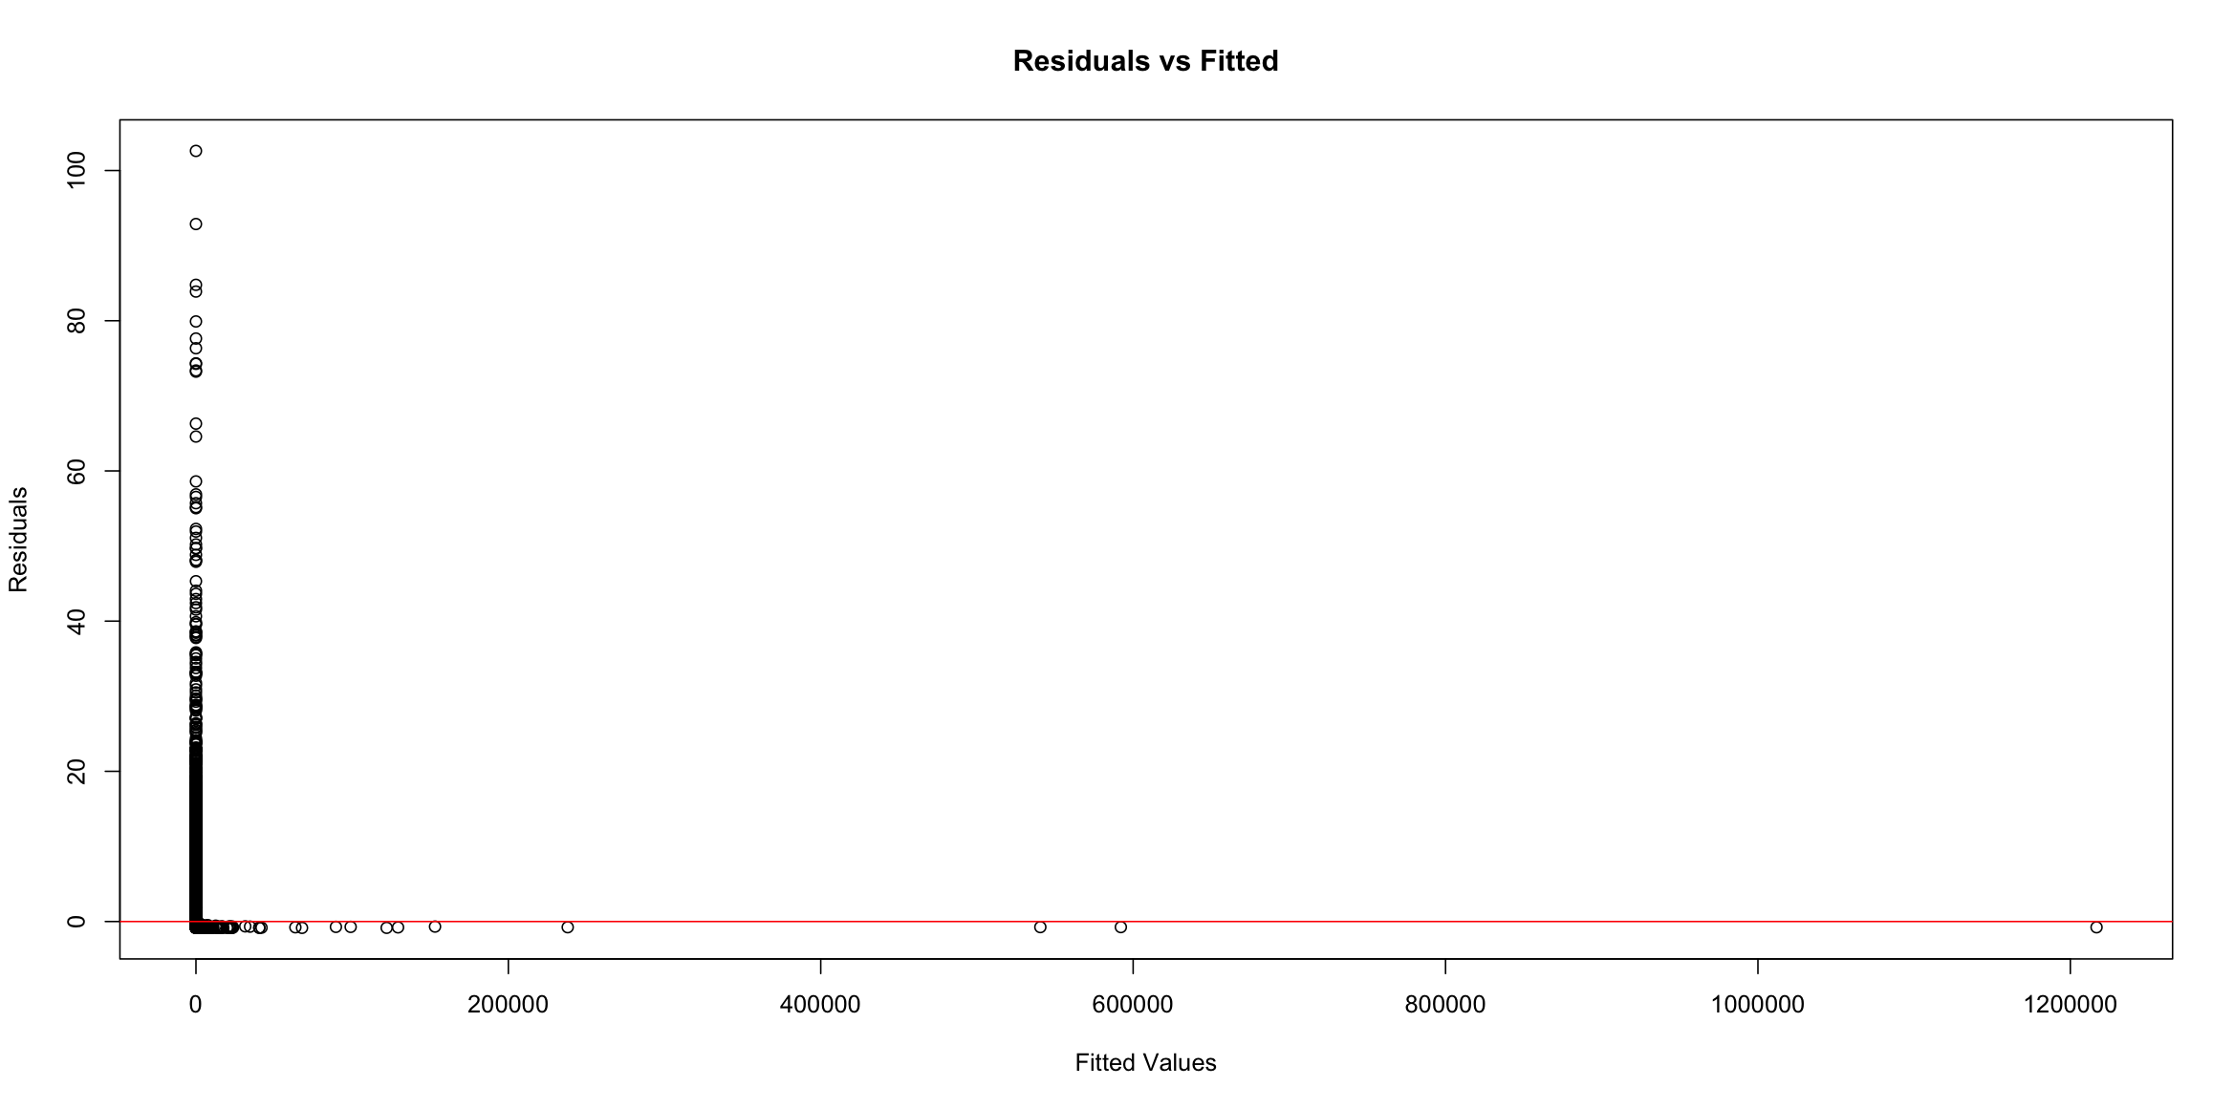Residual Plots:

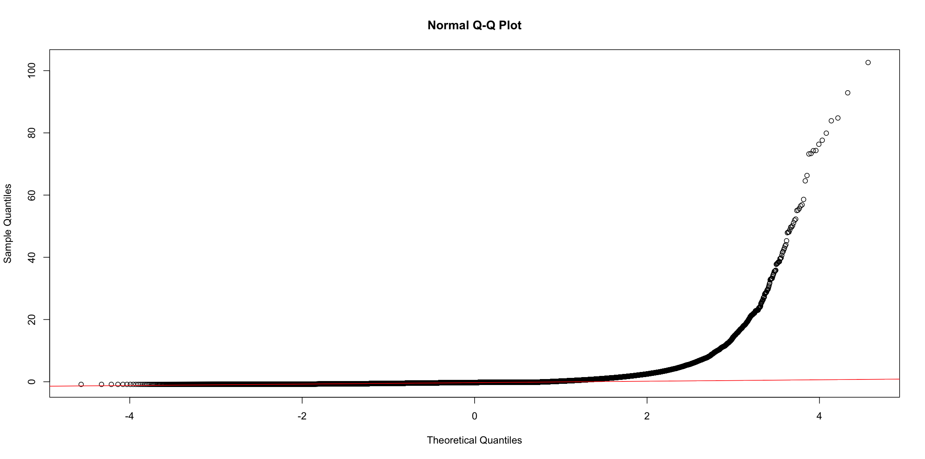QQ-Plot:

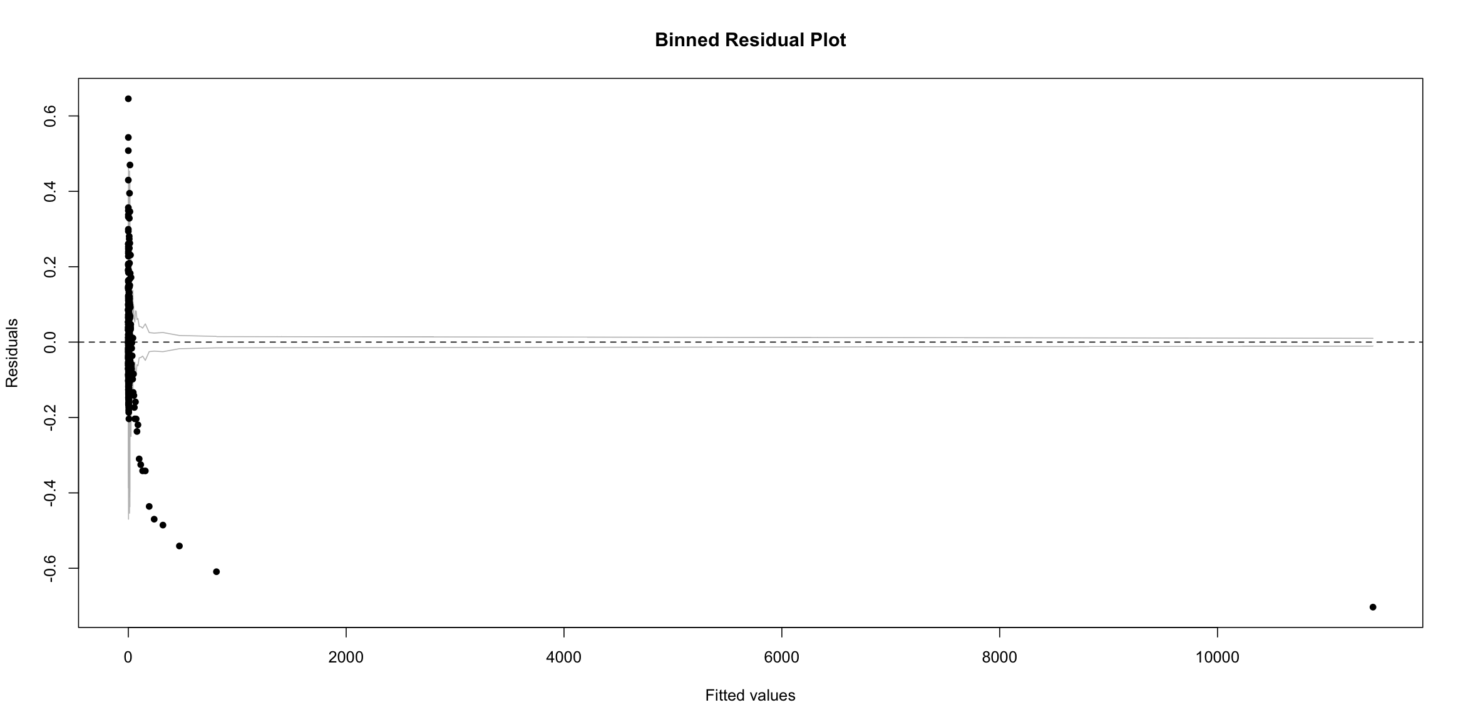Binned Residual Plot:

**Appendix 10. Residual Analysis - Zero Inflation Negative Binomial Regression Model**

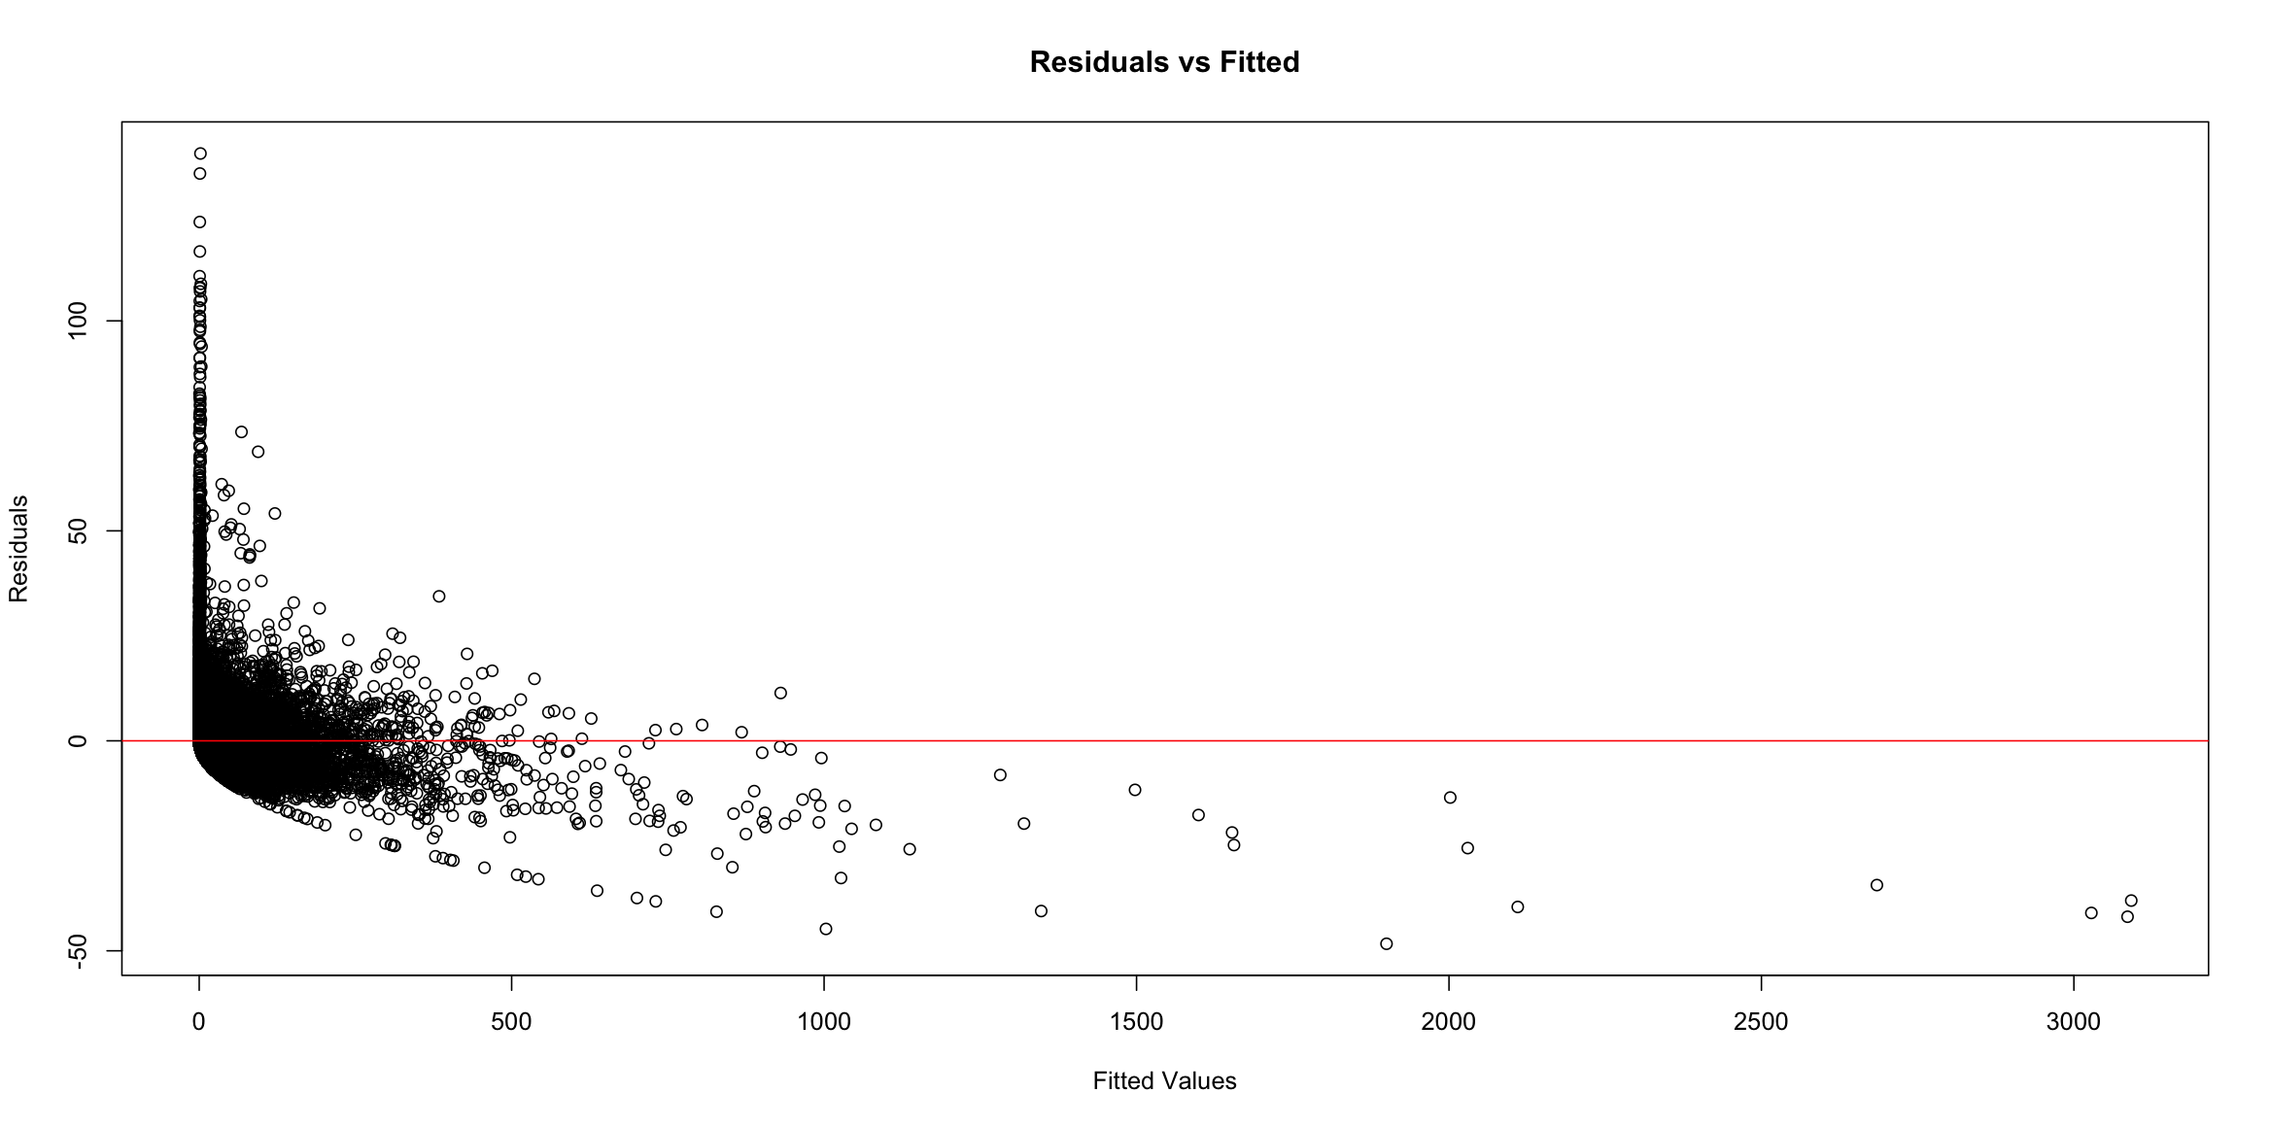Residual Plots:

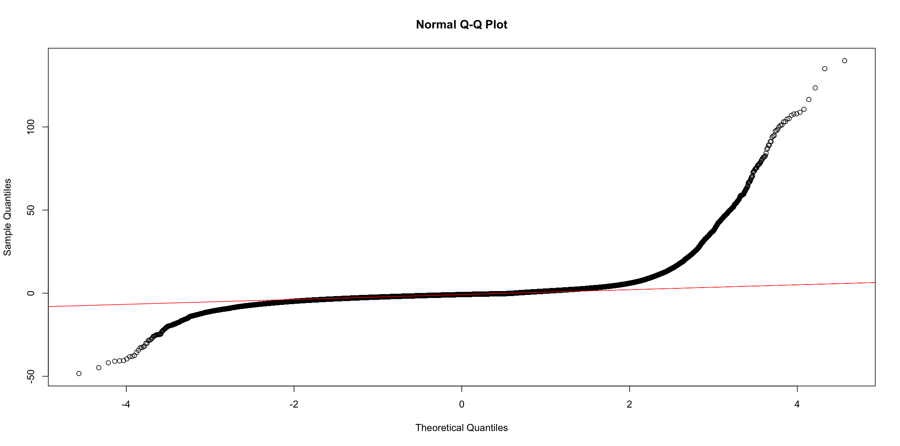QQ-Plot:

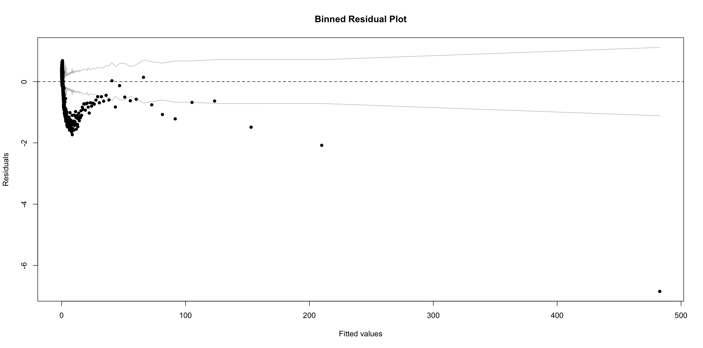Binned Residual Plot:

**Appendix 11. Residual Analysis – Null Model (Negative Binomial Regression Model)**

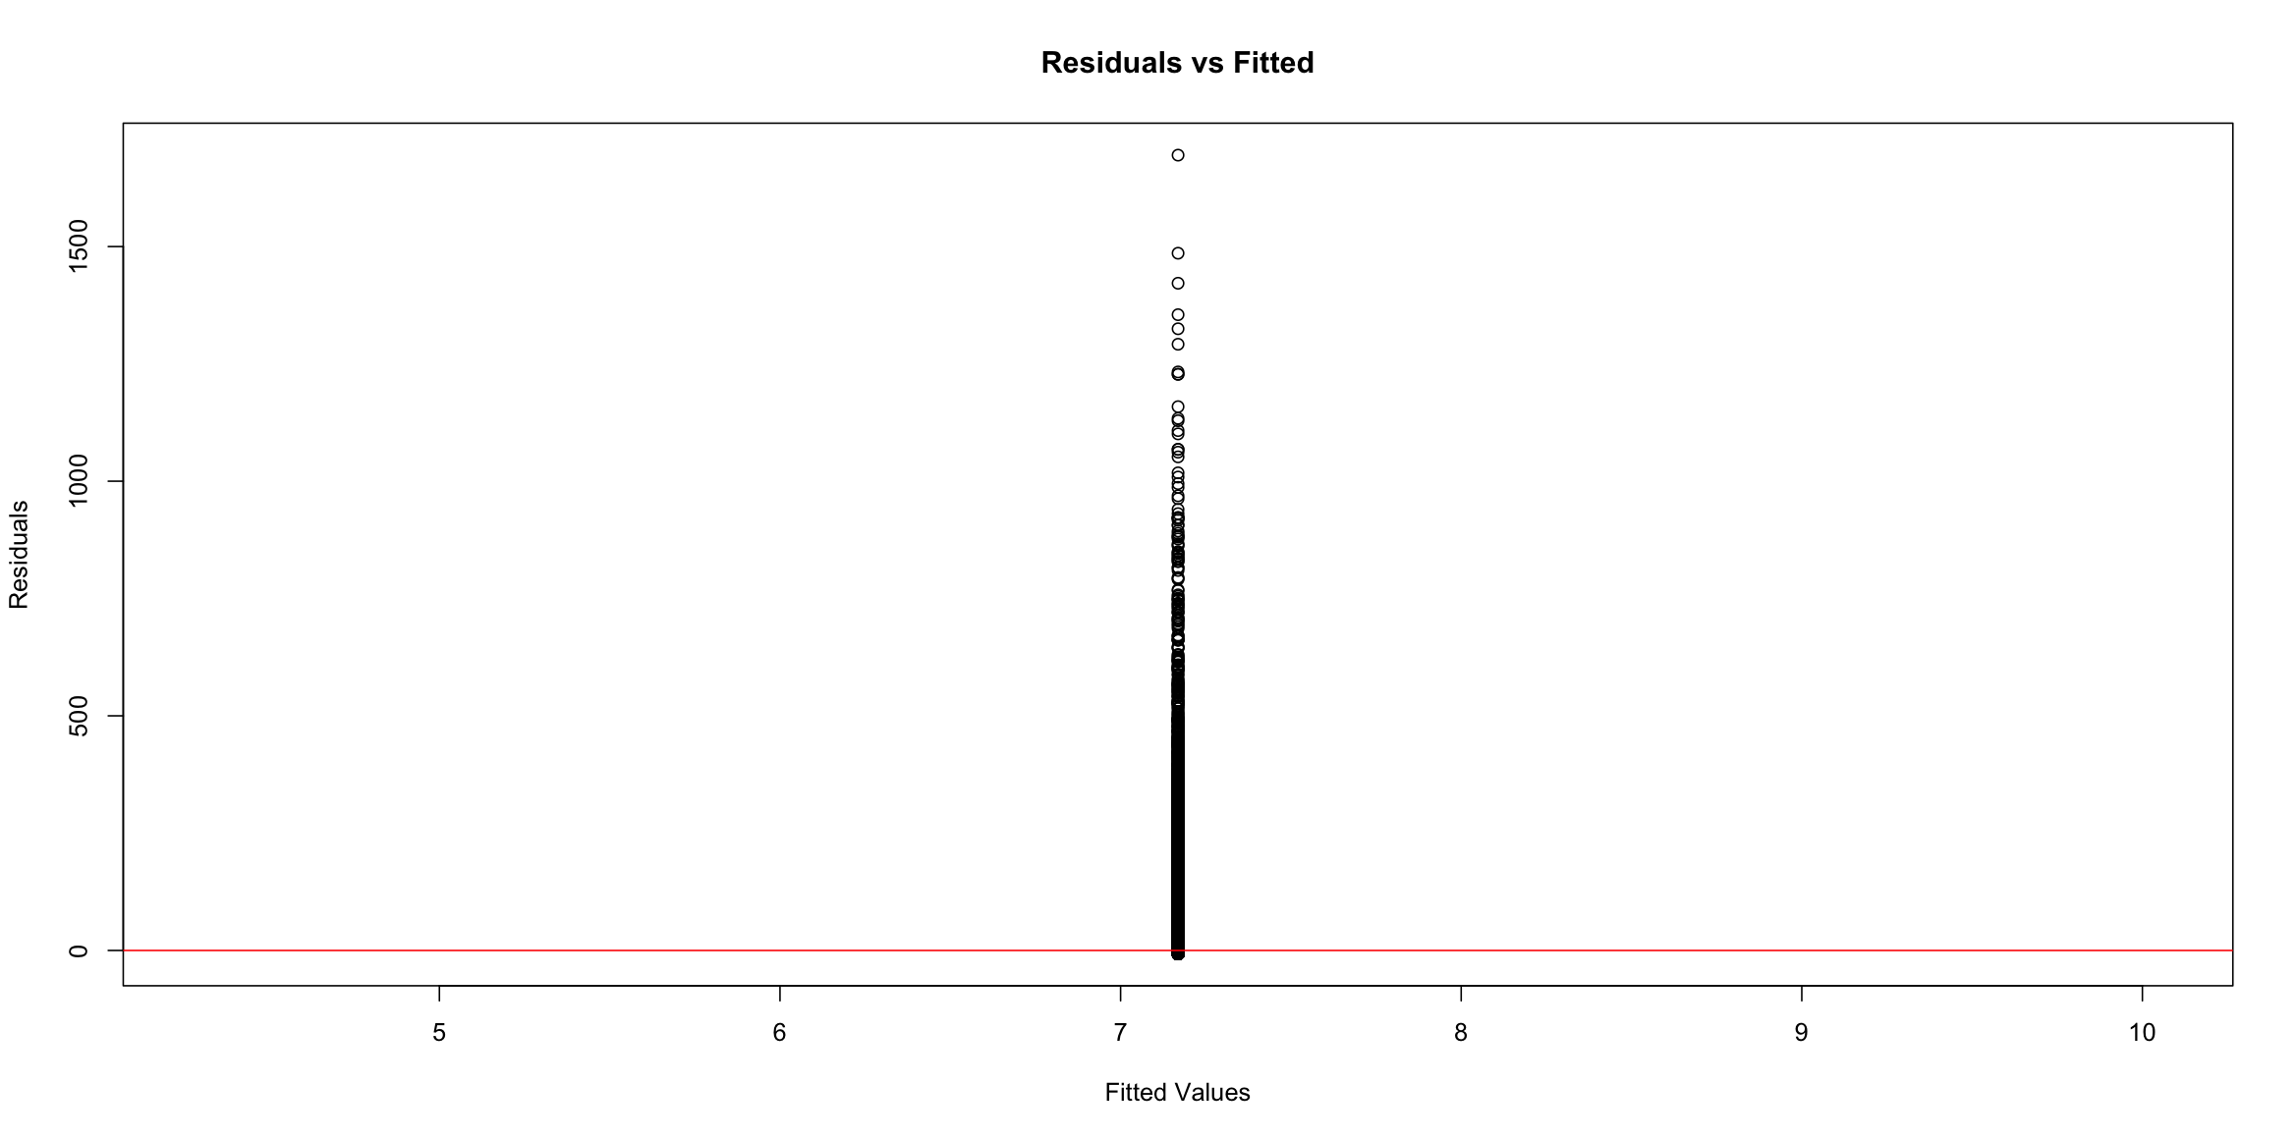Residual Plots:

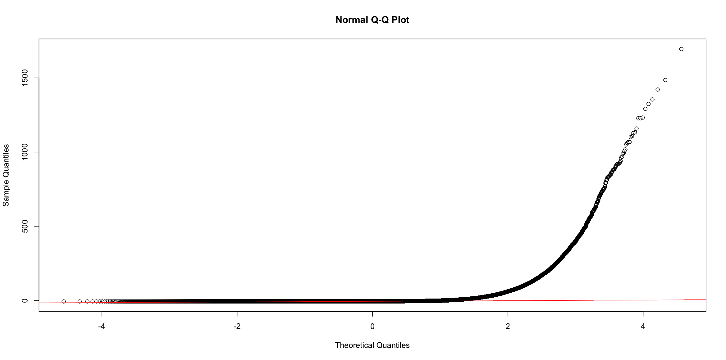QQ-Plot:

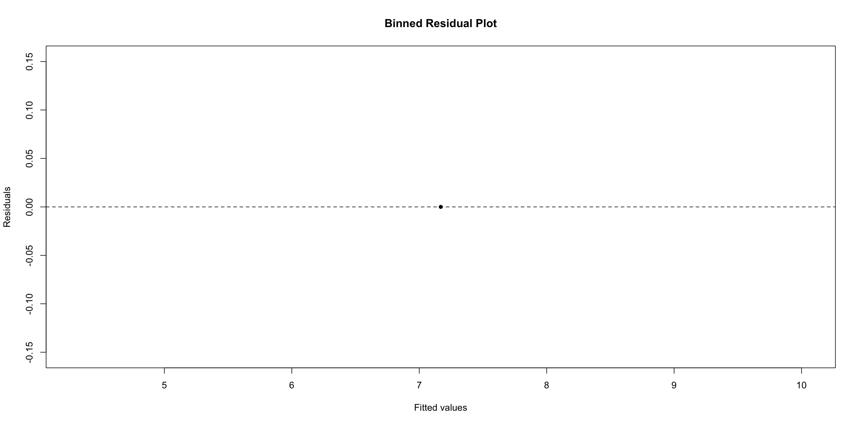Binned Residual Plot:

1. Base date/time is selected to simulated the scenario, as we already know what will happen after this. There is one more kind of time we used in this formulation: is the post published time, which comes before the selected base date/time. See appendix 2 for more information. Singh and Kaur (2015)
2. Data variants are different samples that are collected at different Base date/time. Singh and Kaur (2015) Figure 3.
3. Sig. codes: 0 ‘***’ 0.001 ‘**’ 0.01 ‘*’ 0.05 ‘.’ 0.1 ‘ ’ 1
4. is known as a dispersion parameter in GLM.
5. Null Model Summary: Please refer to Appendix 6.
6. Null Model Summary: Please refer to Appendix 6.